

**Approach to Implementation for MiFID II Costs & Charges Disclosures**

**6 February 2019**

**Version 3.1**

1 Introduction 4

2 Scope of Guide 5

2.1 What this Guide covers: 5

What this Guide does not cover: 5

2.2 5

3 Scope of MiFID II and Costs & Charges 6

3.1 Scope of MiFID II 6

3.2 Scope of MiFID II Costs & Charges Provisions 7

3.2.1 The Costs & Charges requirements 7

3.2.2 Investment Service Costs 9

3.2.3 Investment Product Costs 10

3.2.4 Charges Summary 11

4 Ex-Ante Costs and Charges Disclosure 13

4.1 Introduction 13

4.2 Timing of the Ex-Ante Document 13

4.3 Who creates and who receives the Ex-Ante Costs & Charges Document? 13

4.4 How often does the Ex-Ante Template produced by Product manufacturers need reviewing? 14

4.5 What is a Material Change? 15

4.6 Itemisation of Charge Categories 15

4.6.1 Examples of Product costs 16

4.6.2 How are Product Costs for asset managers obtained? 17

4.6.3 Service Costs 18

4.6.4 How are Service Costs Calculated? 18

4.7 Cumulative Effect of Costs on Return 18

4.8 FX Conversion Rates 19

4.9 Content and Layout 20

5 MiFID II Ex-Ante discretionary portfolio management disclosures 24

5.1 What (general) and who? 24

5.2 Charges Summary 24

5.3 When? 24

5.4 What (more detailed) 25

5.5 Example Ex-Ante DPM Template 26

5.6 Allocating the different costs of a DPM service to the different cost categories in the template 30

6 Ex-Post Fund Manufacturer and Distributor Disclosures 31

6.1.1 Introduction 31

6.1.2 Who creates and receives the Ex-Post data? 31

6.1.3 Method of Ex-Post Data Exchange 32

6.1.4 Timing of Ex-Post disclosures 32

6.1.5 How should the Manufacturer communicate one-off costs to distributors? 34

6.2 Ex-Post Reporting Disclosures for Distributors 34

6.2.1 Content/Template 34

6.2.2 Ex-Post Fund Manufacturer Template 35

6.2.3 Ex-Post Fund Distributor Template 36

6.2.4 Ex-Post Funds Cost and Charges Disclosure – Advisory Portfolio Template 38

6.2.5 Third-party payments received by the investment firm 40

6.3 Disclosure of zero cost where no cost or charge incurred 40

6.4 Fund of Funds and Multi-Strategy Portfolio Reporting 41

6.4.1 Sourcing cost & charges data for Fund of Funds 41

6.4.2 Look-through materiality for multi-strategy portfolios 41

6.4.3 What do we do in the case of non-EEA funds that are not obligated to provide MiFID compliant data? 42

6.4.4 Cumulative Effect of cost and charges on return 43

6.5 Ex-Post Discretionary Portfolio Reporting: Methods of Reporting 44

6.5.1 TISA Discretionary Investment Management Template 44

6.5.2 Article 60 Reporting obligations in respect of portfolio management 45

6.5.3 FCA institutional disclosure reporting 45

7 Guide to categorising cost and charges 47

7.1.1 What information can be sourced from the administrators? 47

7.1.2 One-off charges 47

7.1.3 What charges are contained in the ongoing charges? 47

7.1.4 Incidental Costs 48

7.1.5 Transaction Costs 48

7.1.6 Service Costs 50

7.1.7 Example Breakdown of detailed costs and charges for a “fund” 51

8 Calculation of end investor costs for Ex-Ante and Ex-Post disclosure 53

9 Cumulative Effect of Costs on Return for Ex-Post Reporting 54

10 European MIFID Template (EMT) 56

10.1 About the EMT 56

10.2 Completing the Ex post section of EMT 57

10.2.1 Introduction 57

10.3 The EMT V1.0 spreadsheet is provided below, with the Q&A provided by the EWG. 63

11 Definitions 64

12 APPENDIX 66

12.1.1 MiFID II Directive 2014/65/EU 66

12.1.2 MIFID II Delegated Regulation - Article 50 67

# **Introduction**

This Guide has been prepared to assist MIFID II Asset Management[[1]](#footnote-2) and Distribution[[2]](#footnote-3) firms in the implementation of MiFID II Costs & Charges provisions (effective from 3 January 2018). This document is based on the MIFID II Directive (the Directive), the relevant Delegated Regulation, The European Securities and Markets Authority (ESMA) Questions and Answers on MiFID II and MiFIR Investor Protection Topics (ESMA Q&A) and the initiatives of the European Working Group (EWG).

FCA has implemented the Directive through PS17/14[[3]](#footnote-4). For convenience, this guide refers primarily to the Directive, the Delegated Regulation, the ESMA Q&A and EWG, as these are reflected in the relevant FCA COBS provisions. This guide will continue to be updated as further updates on MIFID II Costs & Charges provisions become available.

Whilst the Guide is primarily intended for UK-based investment firms, MiFID II investment firms operating in other jurisdictions may also find this Guide useful.

# **Scope of Guide**

## What this Guide covers:

This Guide is intended to provide an industry-wide approach to the practical aspects of implementing MiFID II Costs & Charges provisions by providing:

* References to relevant sections of MiFID II legislative documents
* Examples of Ex-Ante and Ex-Post calculation methodologies
* Suggested templates for Ex-Ante And Ex-Post disclosure reports to clients
* Suggestions on timing for disclosures of Ex-Ante and Ex-Post reports to clients
* Reference to the EWG MiFID II template Version 1.0 (EMT) Excel document used for distributing financial instrument data from the product manufacturers to the Distributors.

TISA recognises that each individual investment firm has its own distinct characteristics and there is no ‘one size fits all’ approach. Firms, whether Manufacturers, Distributors or Asset Managers, may modify the approach given here depending upon their own specific circumstances.

## What this Guide does not cover:

This Guide does not cover Ex-Ante and Ex-Post calculation details applicable for product classes such as Structured Products, FX, OTC derivatives, etc.

This Guide does not cover the definition and methodology relating to the *calculation* of transaction costs, specifically the calculation of implicit costs. Readers are referred to the work that the Investment Association (IA) is undertaking in this area[[4]](#footnote-5) and also Annex VI of the PRIIPS Delegated Regulation[[5]](#footnote-6) and related joint ESAs PRIIPS Q & A[[6]](#footnote-7).

Additionally, this Guide does not cover the detail in Article 60 relating to periodic statements in respect of portfolio management of the Commission Delegated Regulation of 25/4/16 supplementing Directive 2014/65/EU (MIFID II Delegated Regulation)[[7]](#footnote-8). The IA has published Guidance on Client Reporting, which covers Article 60 requirements and firms are recommended to follow that guidance in this area.[[8]](#footnote-9)

Individual investment firms are advised to refer to the relevant and latest MiFID II provisions along with the specific rules in the relevant rulebooks in local EU jurisdictions for further guidance on implementation.

# **Scope of MiFID II and Costs & Charges**

## Scope of MiFID II

MIFID II applies to operators of regulated markets and trading venues, and to MIFID investment firms, which carry out investment services or activities in relation to financial instruments. MIFID investment services/activities include:

* Reception and transmission of orders in relation to one or more financial instruments;
* Execution of orders on behalf of clients;
* Dealing on own account;
* Portfolio management;
* Investment advice;
* Placing, and underwriting the placement of, financial instruments.

Certain MIFID ‘ancillary activities’ are also in scope, where they are carried on by a firm alongside ‘mainstream’ MIFID activities. These ancillary activities include:

* Safekeeping and administration of financial instruments for the account of clients, including custody and cash/collateral management;
* Granting credits or loans to an investor to carry out a transaction in financial instruments, where the firm is involved in the transaction;
* Corporate finance advice;
* Foreign exchange services connected to the provision of investment services;
* Investment research and financial analysis or general recommendations relating to transactions in financial instruments.

Firms that are in scope for MIFID II will therefore include dealing platforms, stock brokers, advisers, wealth managers and discretionary and non-discretionary portfolio managers, and banks (in relation to certain services provided to their clients).

Types of business that are generally exempt from MIFID (except to the extent that they also carry on MIFID activities) include:

* Insurers
* UCITS funds and UCITS managers
* AIFs and AIF managers
* Pension funds and pension scheme operators
* Banks (in relation to banking activities that are not MIFID activities).

To be in scope of MIFID II, firms’ MIFID investment services and activities must be provided to clients in relation to ‘financial instruments’, which include:

* Transferable securities (securities which are negotiable on the capital market, including shares and bonds);
* Money-market instruments;
* Units in collective investment undertakings (pooled funds including OEICs, unit trusts and investment trusts);
* Options, futures, swaps and other derivatives
* Contracts for differences.

## Scope of MiFID II Costs & Charges Provisions

The relevant MIFID II provisions covered in this guide are:

* Article 24 of MiFID II Directive 2014/65/EU[[9]](#footnote-10) of the European Parliament and of the Council of 15 May 2014 (MiFID II)
* Recitals 74 to 83 and Articles 50 and 51 of the MIFID II Delegated Regulation[[10]](#footnote-11)
* Annex II of the MIFID II Delegated Regulation[[11]](#footnote-12)
* ESMA Investor Protection Q&A[[12]](#footnote-13)
* FCA policy statement PS 17/14 July 2017[[13]](#footnote-14).

### The Costs & Charges requirements

There are two mandatory Costs & Charges disclosure requirements applicable for investment firms covered by MiFID II:

* **Ex-Ante disclosure** of aggregated *expected costs* for proposed investment services and financial instruments to be provided *in good time* before a client makes an investment decision in the following situations:
  + Where the investment firm recommends or markets financial instrument to clients or
  + Where the investment firm providing any investment services is required to provide a UCITS KIID or PRIIPS KID to clients in relation to the financial instrument.

Where the investment firm does not recommend or market or provide a KID/KIID they must disclose to the client all costs and charges related to the service provided.

When calculating costs and charges on an Ex-Ante basis, investment firms shall base these on costs that have *actually* been incurred as a proxy for the expected costs and charges. Where *actual* costs are not available, the investment firm shall make *reasonable estimations* of these costs.

* **Ex-Post disclosure** of aggregated costs which have *actually been incurred* for investment services and financial instruments, must be provided to each client with which the firm has or has had an ongoing relationship with during the year, *annually on a personalised basis* in the following situations:
  + Where the investment firm recommends or markets financial instrument to clients or
  + Where the investment firm providing any investment services is required to provide to clients a UCITS KIID or a PRIIPS KID in relation to the financial instrument(s).
* Recital 75 of the MiFID II Delegated Regulation confirms that the reference to recommending or marketing financial instruments includes the services of investment advice and portfolio management. Therefore both Ex-Ante and Ex-Post disclosures should be made in relation to the provision of Discretionary Portfolio Management Services.
* For both the Ex-Ante and Ex-Post disclosures, costs should be aggregated and expressed as a *monetary amount and a percentage.* Third party payments received are to be shown separately.
* For both the Ex-Ante and Ex-Post disclosures, *an illustration showing the cumulative impact of costs on the investment return* should also be included along with any anticipated spikes or fluctuations and a description of the illustration.
* Where any part of the total costs and charges is to be paid in or represents an amount of foreign currency, investment firms shall provide an indication of the currency involved and the applicable currency conversion rates and costs.
* *A limited waiver[[14]](#footnote-15)* under certain circumstances is available for Professional Clients (except when the services of investment advice or portfolio management are provided, or when the financial instrument concerned embeds a derivative) and for Eligible Counterparties (except when the financial instrument concerned embeds a derivative and the Eligible counterparty intends to offer it to its clients).

### Investment Service Costs

All costs and associated charges charged for the investment service(s) and/or ancillary services provided to the client should form part of the amount to be disclosed. Cost items should be aggregated as per first column in Table 1 Annex II of the MIFID II Delegated Regulation, which is set out below.

This table refers to both Ex-Ante and Ex-Post disclosures.

**Table 1**

|  |  |  |
| --- | --- | --- |
| **Cost items to be disclosed** | **Description** | **Examples** |
| **One-off charges** related to the provision of an investment service | All costs and charges paid to the investment firm at the beginning or at the end of the provided investment service(s). | Deposit fees,  Termination fees  Switching costs (costs that can be incurred by investors by switching from one investment firm to another investment firm). |
| **On-going charges** related to the provision of an investment service | All on-going costs and charges paid to investment firms for their services provided to the client. | Management fees,  Advisory fees,  Custodian fees. |
| **All costs related to transactions initiated** in the course of the provision of an investment service | All costs and charges that are related to transactions performed by the investment firm or other parties. | Broker commissions (costs that are charged by investment firms for the execution of orders),  Entry- and exit charges paid to the fund manager,  Platform fees,  Mark ups (embedded in the transaction price),  Stamp duty,  Transactions tax  Foreign exchange costs. |
| **Any charges that are related to ancillary services** | Any costs and charges that are related to ancillary services that are not included in the costs mentioned above. | Research costs.  Custody costs. |
| **Incidental costs** |  | Performance fees |

***Table 1 of Annex II of MiFID Delegated Regulation***

### Investment Product Costs

All costs and associated charges related to the financial instrument that should form part of the amount to be disclosed. Cost items should be aggregated as per the first column in Table 2 Annex II of the MIFID II Delegated Regulation, which is set out below.

This table refers to both Ex-Ante and Ex-Post disclosures.

**Table 2**

|  |  |  |
| --- | --- | --- |
| **Cost items to be disclosed** | **Description** | **Examples** |
| **One-off charges** | All costs and charges (included in the price or in addition to the price of the financial instrument) paid to product suppliers at the beginning or at the end of the investment in the financial instrument. | Front-loaded management fee  Structuring fee (fees charged by manufacturers of structured investment products for structuring the products. They may cover a broader range of services provided by the manufacturer)  Distribution fee. |
| **On-going charges** | All on-going costs and charges related to the management of the financial product that are deducted from the value of the financial instrument during the investment in the financial instrument. | Management fees,  Service costs,  Swap fees,  Securities lending costs and taxes, financing costs. |
| **All costs related to transactions** | All costs and charges that incurred as a result of the acquisition and disposal of investments. | Broker commissions,  Entry- and exit charges paid by the fund, mark ups embedded in the transaction price,  Stamp duty,  Transactions tax  Foreign exchange costs. |
| **Incidental costs** |  | Performance fees |

***Table 2 of Annex II of MiFID Delegated Regulation***

It should be noted that certain cost items appear in both tables but are not duplicative since they respectively refer to costs of the product and costs of the service. Examples of these include:

* Management fees in Table 1 - this refers to management fees charged by an investment firm providing the service of portfolio management to its clients while in Table 2 it refers to management fees charged by an investment fund manager to its investor.
* Broker commissions in Table 1 - this refers to commissions incurred by the investment firm when trading on behalf of its clients while in Table 2 it refers to commissions paid by investment funds when trading on behalf of the fund.

### Charges Summary

It is a mandatory requirement to show the aggregated totals of Product, Service and any Third party payments received. These figures must be shown as both a percentage amount, and currency/monetary figure.

The ESMA Investor Protection Q&A Q.13 offers additional guidance on the Charges Summary.

**Question 13 [Last update: 6 June 2017]**

*When providing information of costs and charges to clients, on which basis should costs be aggregated? What is the level of aggregation that firms need to apply?*

**Answer 13**

“In accordance with article 24(4) MiFID II and article 50(2) of the MiFID II Delegated Regulation, firms shall aggregate costs and charges in connection with the investment service and costs and charges associated with the financial instruments. Third party payments received by investment firms in connection with the investment service provided to a client shall be itemised separately. The aggregated costs and charges shall be totalled and expressed both as a cash amount and as a percentage. The following example shows the cost figures that are to be disclosed”

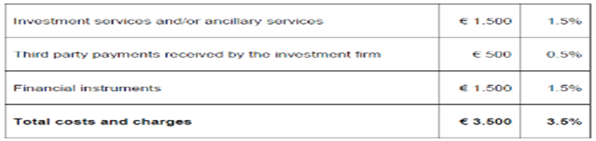

**Third-Party Payments**

“Third Party payments received by investment firms or other parties in connection with the investment service provided to a client shall be itemised separately and the aggregated costs and charges shall be totalled and expressed both as a cash amount and as a percentage”

* This typically relates to retrocession or commission payments received by the investment firm. An Ex-Ante template produced by a distributor is more likely to have items within this category than a product manufacturer as the product manufacturer pays retrocession, whilst the product distributor receives retrocession.
* An Ex-Ante disclosure would contain generic cost percentages to be added to the illustration. Care must be taken not to double-count any costs in both the third party Cost category as well as the Product Cost bucket.

# **Ex-Ante Costs and Charges Disclosure**

## Introduction

This section describes the suggested steps a firm might take to comply with the MiFID II Ex-Ante Costs and Charges requirements for Funds - in terms of content, production, high level calculation and layout. The high level requirements for disclosure are detailed in the MiFID II Directive[[15]](#footnote-16) Section 2, Article 24(4), and supplemented by MiFID II Delegated Regulation[[16]](#footnote-17) Article 50.

## Timing of the Ex-Ante Document

An investor must be able to see the costs and charges applicable in good time before the provision of services. This is to enable comparison of costs between different products (including service costs) in order to make informed investment choices.

For execution only (XO) and advisory business investing in funds, a client will typically invest via:

* A web portal
* The telephone
* A postal application form.

Each of these methods of investing should include the provision of Ex-Ante information to the client. For example, in relation to clients trading via web portals, a click-through acknowledgement could be implemented to ensure that the provider of the Ex-Ante documentation has met their regulatory obligations (similar to the approach to the provision of the UCITS KIID). Other methods of communicating include email or hard copies, which will necessitate amendments to documentation and telephone scripts.

## Who creates and who receives the Ex-Ante Costs & Charges Document?

MiFID II cost disclosure involves reporting ALL costs and charges to the client prior to the client’s investment being completed. This includes not only product costs but also service costs.

Funds can be sold to an end client at a number of points in the distribution chain, and the costs shown to potential clients should be correct at each point in the chain.

Product Manufacturers need to calculate the costs of the financial instrument (i.e., the product costs). If selling the product direct to clients, any additional costs associated with the service (i.e., service costs) must also be captured and included within the Ex-Ante document.

The Ex-Ante template displayed to end clients must include the product costs from the manufacturer and any additional service costs added by different service providers in the chain. Whilst the product costs should remain constant throughout the chain, Platforms, Distributors, Fund Supermarkets and agents may all add additional service charges, which would need incorporating into any Ex-Ante template shown to the client.

To facilitate the provision of the product charges from the product manufacturer to other participants in the chain, a data template or flat file referred to as the EMT (which is a standardized format developed by European Working Group (EWG) should be utilised. This will be detailed in Chapter 10.



## How often does the Ex-Ante Template produced by Product manufacturers need reviewing?

*“Where calculating costs and charges on an Ex-Ante basis, investment firms shall use actually incurred costs as a proxy for the expected costs and charges. Where actual costs are not available, the investment firm shall make reasonable estimations of these costs. Investment firms shall review Ex-Ante assumptions based on the Ex-Post experience and shall make adjustment to these assumptions, where necessary.”*

Ex-Ante templates are to be reviewed at least annually in light of new Ex-Post data. Any material change to the product costs that occur during the year should trigger a republication of the template.

## What is a Material Change?

Materiality for MiFID II is not currently defined. It is up to firms to determine what consists of a material change for their particular purposes. Overall, any circumstances that might result in a change that affects or is likely to affect the accuracy, fairness or clarity of the information could be considered a material event. It may help firms to consider the AIFM level 2 definition of material change.  *Any changes in information shall be deemed material if there is a substantial likelihood that a reasonable investor, becoming aware of such information, would reconsider its investment, including because such information could impact an investor’s ability to exercise its rights in relation to its investment, or otherwise prejudice the interests of one or more investors[[17]](#footnote-18).*

## Itemisation of Charge Categories

Whilst there is no predefined layout for the Ex-Ante template, there are however pre-defined categories for the itemisation of the product and the service costs. This detail must be readily available if requested by the client.

The ESMA Investor Protection Q&A 13 states:

*“In addition, the investment firm shall provide an itemised breakdown at the request of the client. ESMA would expect that an investment firm take reasonable steps to minimise the effort for the client to submit such requests. When disclosing costs and charges in an online environment for instance, a best practice would be to enable the client to access such information through the use of hyperlinks. ESMA also considers it a best practice when an investment firm actively informs its clients on their right of submitting such a request when providing the aggregated information.*

*When an itemized breakdown is requested by the client, an investment firm should provide such breakdown (in a consistent way such that cost items may be aggregated) at least at the level of the cost items that are depicted in the tables included in Annex II MiFID II Delegated Regulation”*

Some investment firms may wish to provide a further level of granularity, but the tables in Annex II[[18]](#footnote-19) are the minimum requirement. See sections 3.2.2 and 3.2.3.

### Examples of Product costs

Products Costs are costs incurred by the fund that apply equally to all investors. The table below provides some further information of product cost items for funds.

| **Field** | **Description** |
| --- | --- |
| One-off Costs | One-off Costs include entry and exit costs. Some funds may charge an x% charge when investors are buying into the product. This amount will reduce the actual amount being invested. For example a £1,000 investment in a fund with a 3% entry cost will result in a £970 holding in the product.  One-off Costs are applied to the gross investment amount |
| Ongoing Costs | All fund costs and expenses, including the Annual Management Charge. |
| Transactions Costs | Transactions costs can be divided into Explicit and Implicit Costs  Explicit – the brokerage, tax and commission charges added to the transaction settlement amount. These costs can be clearly identified and quantified.  Implicit – the Arrival Cost or Slippage. ESMA suggests MiFID II will read across to the PRIIPs regulatory text for the calculation methodology pertaining to the Arrival Cost. |
| Incidental Costs | The performance fees  If historically a performance fee has been charged but has subsequently been eliminated, then you should show n/a.[[19]](#footnote-20)  Performance fees apply to the net investment amount (after entry costs) |

Please see Chapter 7 for further detail on which types of costs roll up to which categories.

### How are Product Costs for asset managers obtained?

Product costs will be made available where firms are using the EMT, which TISA has endorsed, or equivalent data exchange process. This section explains how product suppliers calculate the figures therein.

One-off Costs

* Entry costs are represented as % figures (according to the suppliers actual charging policy and not the amounts reserved in the prospectus) and applied to the initial investment amount.
* Historical data is not used to determine the Ex-Ante one-off costs for a fund.

Ongoing Costs

* Actual ongoing charges calculated for the UCITS KIID or the PRIIPs KID (excluding performance fees) for the product over a 12 month period.
* Expressed as a percentage of the average NAV of the product over the same period. (N.B. NAV/AUM of the fund, not the share class price)
* Where a fund holds an underlying fund, the underlying fund’s charges will have been incorporated into the ongoing charges figure.

Transaction Costs

There are two types of transactions costs - explicit and implicit costs.

* **Explicit costs** are costs charged to and paid directly by the fund and include Brokers Commission, Transaction Taxes and Fees, these should all be known or easily identifiable by the investment managers’ order management and transaction cost analysis systems.
* **Implicit Costs** are not an actual discrete cost charged to a fund, implicit costs under the Arrival Price methodology relate to the cost differential between the mid-market price of an asset immediately before the order is placed in the market and the price that the deal is struck at. It represents the loss of value of taking an asset into a fund. The implicit cost could be either positive or negative and could vary greatly dependent on the liquidity of the stock being invested in, with smaller cap stocks having a larger spreads the dealing costs for these and the overall cost for small cap funds could be larger than those of a large cap fund investing in more liquid assets.
* Transaction costs are expressed as % per annum of the average NAV.

To note – the PRIIPS Delegated Regulation[[20]](#footnote-21) along with the joint ESAs PRIIPS Q & A[[21]](#footnote-22) provide further detail on the transaction cost calculations.

Incidental Costs

* Performance fees and/or carried interest for the product expressed % per annum of the average NAV.

### Service Costs

Investment Firms must capture all costs that are charged to their clients for the provision of the investment service. Some examples relating to funds are set out below.

| **Field** | **Description** |
| --- | --- |
| One-off Costs | Switching or dealing fees, PTM levies, deposit fees |
| Ongoing Costs | Account charges or annual service fees |
| Transactions Costs | FX charges to convert the client flow into share-class currency when working with multi-currency funds, platform fees, transactions tax, broker commissions (charged by investment firms for the execution of trades) |
| Ancillary Costs | Other costs relating to ancillary services not mentioned above |
| Incidental Costs | Performance fees |

**Please see Chapter 7 for further detail on which types of costs roll up to which categories.**

### How are Service Costs Calculated?

* Service costs may not affect all investors equally, and are not always predictable.
* A key challenge for the Ex-Ante template is how to present the service costs so as to present the client with scenarios applicable to their own investment plan.

For example: if a particular product was available both within a wrapper, and outside a wrapper, and both of these options had different costs applicable, then the template will need to illustrate both of these scenarios, using text, graphs and/or tables.

## Cumulative Effect of Costs on Return

*“Investment firms shall provide their clients with an illustration showing the cumulative effect of costs on return when providing investment services. Such an illustration shall be provided both on an Ex-Ante and Ex-Post basis. Investment firms shall ensure that the illustration meets the following requirements:*

*(a) The illustration shows the effect of the overall costs and charges on the return of the investment;*

*(b) The illustration shows any anticipated spikes or fluctuations in the costs; and*

*(c) The illustration is accompanied by a description of the illustration. “*

* This translates to a requirement to compare what the return of the fund would be if there were no charges with the return of the fund after all charges.
* There is no guidance on what growth rate (if any) to use in the illustration. One possible solution is to align to the PRIIPs approach.
* The difference in the return received net verses gross can be expressed in percentage terms, monetary terms or both.

There are varying degrees of complexity that could be involved in this calculation. For the Ex-Ante funds illustration, an underlying assumption is that the fees are taken from the fund evenly throughout the year. By adding back in the fees and the performance that would have been accrued on those fees, a gross return figure can be calculated.

One method of calculating the gross return (for a given net growth rate and annualised costs) is as follows:

* Day 1:
  1. Take the net investment amount
  2. Apply the net growth rate to the investment amount on a daily basis
  3. Add back each day’s fees back to the investment amount
  4. Result = gross value at end of day 1
* Day 2 (and repeat)
  + Take the gross value (4) from above
  + Repeat steps 2-4

The net return = Net investment amount x net growth rate.

**Further details are set out in Chapter 10.**

## FX Conversion Rates

The following text appears in Article 50 Paragraph 3 of the MiFID II Delegated Regulation

*3. Where any part of the total costs and charges is to be paid in or represents an amount of foreign currency, investment firms shall provide an indication of the currency involved and the applicable currency conversion rates and costs. Investments firms shall also inform about the arrangements for payment or other performance*.

TISA’s view is that this translates to a requirement to detail the impact of any FX rates utilised at the point of translating the Ex-Ante document from one currency to another. For example, if product costs were calculated in annualised % terms, then the impact of using different currencies to illustrate the template will not invoke this requirement. However, if certain Service Costs are expressed in fixed currency terms (for example if a Sterling Fund incurred a £50 dealing charge), then if the Ex-Ante template was issued in a currency other than £, the impact of this FX conversion should be detailed using the FX rates at the point of document production.

## Content and Layout

The regulator has deliberately[[22]](#footnote-23) not defined a prescribed format or layout for Ex-Ante disclosure. Accordingly, investment firms are free to design their own template formats.

TISA has developed examples of Ex-Ante templates that firms can use as a basis for their own templates for the following:

* Funds
* Investment Trusts
* Discretionary Portfolio Management.

These are meant as a guide only, but should provide a good starting point for complying with the Ex-Ante requirements. These templates can be rendered on web pages, emailed, hyperlinked as .pdf documents, and/or provided in hard copy format.

Below is an example of an Ex-Ante template for a fund – as might be produced by a product manufacturer. Clients can see charges for two different investment amounts, and can see typical charges for a regular savings plan that uses a popular monthly savings amount in its illustration. There are no service charges for this particular illustration, which is not unusual for a product manufacturer.

***Disclaimer: this data / these figures are not representative of any specific product and are solely for illustration purposes***

**Example 1 - Fund Manufacturer Ex-Ante Execution Only Template – Funds**

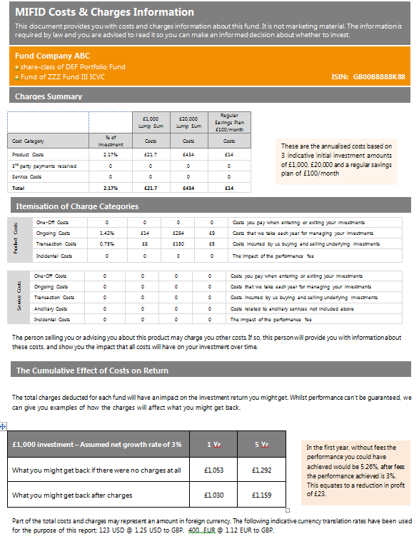

Below is an example of an Investment Trust Ex-Ante template. Clients can see charges for a number of different service options offered. Entry costs are applicable so there would be anticipated spikes in year 1 compared to subsequent years. This has been illustrated via a narrative.

***Disclaimer: this data / these figures are not representative of any specific product and are solely for illustration purposes***

**Example 2- Ex-Ante Execution Only Template – Investment Trusts**

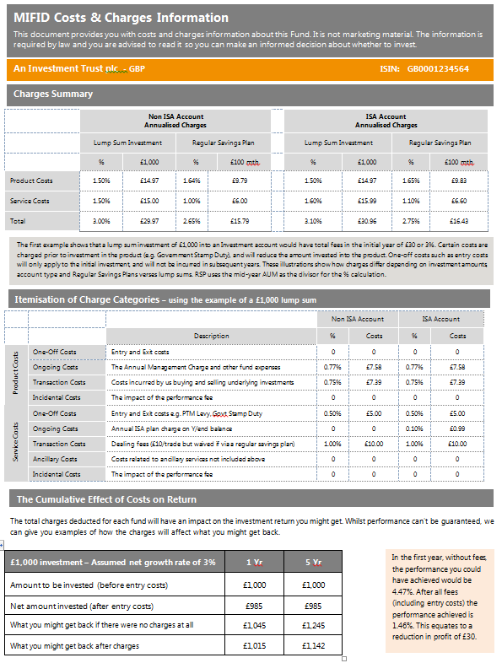

* 1. **The Execution-Only Template for Funds**

For an execution-only relationship, where a client may typically be investing via a web portal, and no prior engagement/discussion with the client has been undertaken, very little maybe known about the size of any potential trade, or any other investment decisions which may affect the charges applicable. Different illustrations should be utilised to help bring out these differences and make it as easy as possible for the client to understand the relevant charges applicable to their own potential investment. Illustrations can include graphs, numbers or purely text.

Some investment firms may implement a more interactive solution that could tailor the template to be more specific to the potential investor’s investment amount or other variables.

Whatever the level of sophistication involved, the Ex-Ante template *must* be sufficient for a potential investor to understand the impact of ALL costs and charges on any potential investment.

TISA recommends that clients be provided with the breakdown per Annex 2 of the MiFID II Delegated Regulation up-front rather than only upon request (See Sections 3.2.2 and 3.2.3).

Q14 of the ESMA Investor Protection Q&A[[23]](#footnote-24) is fairly clear on what should be provided.

*“In line with recital 78 of the MiFID II Delegated Regulation, investment firms should disclose the costs associated with the products and the service the client intends to subscribe to. In the case of potential clients, adapting the information may only be possible when the potential client has engaged with the investment firm. Until then, investment firms could disclose generic ex-ante information on costs and charges using other means, such as disclosing costs and charges for several examples of investor types, providing online access to interactive cost calculation tools or providing cost tables that include multiple investment scenarios.”*

The period of time that the template looks forward is not prescribed in the regulatory text, but clearly firms should provide illustrations that factor in any charges that might occur during the lifecycle of the investment.

# **MiFID II Ex-Ante discretionary portfolio management disclosures**

## What (general) and who?

This section of the Guide relates to the Ex-Ante disclosures MiFID investment firms are to provide to their discretionary portfolio management clients (“DPM Clients”) under Article 50(6) of the MiFID II Delegated Regulation.

The obligation under Article 50(6) here is taken to mean that discretionary portfolio managers must disclose to their DPM Clients an aggregate estimate of all costs and charges for the proposed investment service (“Ex-Ante DPM Disclosure”) prior to the DPM service being provided.

Firms should note that, as part of the provision of DPM service, the costs of buying and selling the financial instruments within the mandate, as well as any other costs associated with these financial instruments (for example (but not limited to) an underlying fund’s ongoing charges and transaction costs) must also be disclosed as part of the Ex-Ante DPM Disclosure. Please see Sections 3.2.2 and 3.2.3 for more detail.

## Charges Summary

It is a mandatory requirement to show the aggregated totals of Product, Service and any third-party payments received. These figures must be shown as a percentage and monetary amount. As mentioned in the Ex-Ante Funds chapter of this document above, ESMA Investor Protection Q&A Q.13 offers guidance on the aggregation of the charges summary. Firms should at least provide clients with the following level of information.

* Investment services and/or ancillary services
* Third party payments received by the investment firm
* Financial instruments.

Please see section 3.2.4 above for further information on third-party payments.

## When?

New clients

MiFID investment firms must provide all new DPM clients this Ex-Ante DPM disclosure in good time **prior to** the provision of the investment service. This should be included as part of the client on-boarding process, however firms can provide this information at an earlier stage of the client process (such as RFP/pitch stage) if desired. Firms should, in any case, send an updated MiFID 2 Ex-Ante DPM disclosure before the investment management agreement is signed.

Existing clients (both pre and post 3 Jan 2018)

We recommend that Ex-Ante DPM Disclosure should be provided only in relation to any change to the mandate and/or services provided which would materially impact the client’s costs and charges. Such changes to the mandates could include, but are not limited to, changes to management fees and changes to investment strategies.

## What (more detailed)

There is no pre-defined layout for the Ex-Ante DPM Template. There are however pre-defined categories for the itemisation of product and service costs. This must be readily available if requested by the client. Some firms may want to provide a further level of granularity, but the tables in Annex II of the MiFID II Delegated Regulation are the minimum requirement. Please see Sections 3.2.2 and 3.2.3 for details of these pre-defined categories and also Chapter 8 for a further discussion of how this applies to DPM.

In relation to the Costs and Charges Summary, the first section of the sample template disclosure below, the period of data reported on is one year (and subsequent one-year periods, where relevant), presenting annualised figures. See a sample disclosure set out below.

**In relation to the Cumulative Effect of Fees section of the template-**

**ESMA’s guidance in their MiFID 2 Investor Protection Q&A notes that when the investment service provided to the client will involve an ongoing relationship (as is the case for DPM relationships), the Ex-Ante cost estimation would need to cover a certain period. In this case the investment firm would be required to apply an additional set of forward looking assumptions on the client’s investment portfolio and the expected investment service(s).** Therefore TISA suggests the periods of data reported on are 1) first year and 2) other relevant time period. Regarding the other relevant time period, if the portfolio or service has a recommended holding period/time horizon, we suggest this should be the period displayed. In other cases, TISA suggests this should be a reasonable reflection or assumption of the expected client relationship, or the period of the Ex-Ante estimation**.** See a sample disclosure set out below.

When calculating costs on an Ex-Ante basis, investment firms shall use actually incurred costs as a proxy for the expected costs and charges (for example, in a model portfolio situation). Where actual costs are not available, the investment firm shall make reasonable estimations of these costs. (TISA suggests for example, that in some circumstances it might be reasonable for the Ex-Ante disclosure to be based on actual Ex-Post amounts incurred for a similar portfolio run for another client. Again this will be up to the firm to use their judgment on whether the portfolio has similar enough investment strategy, asset classes, parameters etc. to deem it a reasonable estimate.)

Investment firms should review Ex-Ante assumptions based on the Ex-Post experience and make adjustments to these assumptions where necessary.

## Example Ex-Ante DPM Template

Whilst the regulators have not defined the layouts for the cost and charges disclosers, below is a sample template for an Ex-Ante DPM disclosure. This template is illustrative rather than prescriptive. This template is meant as a guide only, but should provide a good starting point for complying with the Ex-Ante requirements. This template can be rendered on web pages, emailed, hyperlinked as .pdf documents, and/or provided in hard copy format.

**Disclaimer: this data / these figures are not representative of any portfolio manager and are solely for illustration purposes**

**Ex-Ante Costs and Charges Disclosure for Discretionary Portfolio:**

**MiFID II Costs and Charges Information**

*This document provides with you with expected costs and charges information about the proposed mandate. It is not marketing material. This information is required by law and you are advised to read it so you can make an informed decision about whether to invest.*

*Where possible, ABCXYZ Investments have used actually incurred costs as a proxy for the expected costs and charges. Where actual costs are not available, ABCXYZ Investments have made reasonable estimations of these costs. Charges may vary from year to year. [These are example disclaimers - firms themselves should consider relevant disclaimers]*

*The examples below are based on a client investing £500,000,000 through an investment management agreement (IMA) for ABCXYZ investments to manage the total investment amount on behalf of the client. The total charges deducted will have an impact on the investment return you might get.*

**Costs and Charges Summary**

******



Firms may also wish to consider if they would like to put in a description of the different types of charges, like in other example templates in this guide.

***PLEASE NOTE - ABOVE AND BELOW TABLES ARE NOT REGULATORY MANDATORY – ONLY REGULATORY APPLICABLE VIA “AD-HOC REQUEST”. HOWEVER BEST PRACTICE SUGGESTING TO INCLUDE***

**These are annualised anticipated costs over the first year and a subsequent years period.**

**The Cumulative Effect of Costs on Return**

*While performance can’t be guaranteed, we can give you examples of how the charges will affect what you might get back and the illustration below shows you the effect charges have when comparing the return before and after fees. ABCXYZ Investments do not recommend a holding period for your portfolio, but for illustration purposes the information below relating to impacts that charges may have on your return is based on a 1 year period and [five] years period. Past performance is not a guide to future performance. The value of investments may go down as well as up and cannot be guaranteed; an investor may receive back less than their original investment. [These are example disclaimers - firms themselves should consider relevant disclaimers]*

Use of net growth rate of 3% is illustrative, not prescriptive



*.*

**Please note** – as noted above, the aim of this template is to give suggestions around the **format/layout** of the relevant disclosures and as such, the calculated £ numbers and percentages (together “figures”) contained in this example template and associated narrative below are only for illustrative purposes. Therefore, and for the avoidance of doubt, the figures in this cumulative effect of costs on return section **should not to be** relied upon by firms, including in respect of the creation or validation of firms’ own calculation methodology for the cumulative effect of costs on return - i.e. firms should not use these figures to create or validate their own cumulative effect of costs on return calculation methodologies.

**Description of the illustration of the cumulative effect of costs on return:**

In Year 1, without fees the performance you could have achieved would be 5.23%, after fees the performance achieved is 3%. This equates to a reduction in return of £11,132,368.75.”

Over 5 years, without fees the performance you could have achieved would be 28.53%, after fees the performance achieved is 15.93%. This equates to a reduction in return of £63,006,918.99.

*Put following information in where necessary* – The reason why this percentage may differ from the total percentage shown in the table above is because of the potential impact of charges on the return you would have received if there had been no charges at all.

*Part of the total costs and charges incurred in the future may represent an amount in foreign currency. The following indicative currency translation rates have been used for the purpose of this ex-ante example: 12,000.00 USD @ 1.25 USD to GBP, 5,000.00 EUR @ 1.12 EUR to GBP.*

**Illustration of cumulative effect of costs on return** – please see the Chapter 9 for details on our recommendations on the requirement to show an illustration showing the cumulative effect of costs on return when providing investment services on an Ex-Ante basis.

Additionally, the ESMA Investor Protection Q&A Q14 set out below provides relevant guidance on how to approach Ex-Ante disclosures. The bits in bold are of particular relevance to the Ex-Ante DPM Disclosure:

**Question 14 [Last update: 6 June 2017]**

*How should investment firms provide ex-ante disclosure of information on costs and charges to clients when there is no available data on actually incurred costs?*

**Answer 14**

Based on article 50(8) of the MiFID II Delegated Regulation, when calculating costs and charges on an ex-ante basis, **an investment firm shall use actually incurred costs as a proxy for the expected costs and charges. There may be circumstances where such data is not (entirely) available, for instance during the first year after MiFID II has become effective, when an investment firm just started business or in the case of new clients. In these cases, the investment firm should make reasonable estimations of the expected costs and charges.**

ESMA considers an **estimation to be reasonable when it includes all variables that directly impact the costs and charges that are expected to be incurred by the client, using actual data to the extent available and making reasonable assumptions otherwise**. Examples of such variables are in the case of executing a transaction:

* The type of financial instrument the client wants to buy or sell;
* The cost of the financial instrument, if any;
* The transaction size;
* The commission that will be paid to the broker for executing the order;
* Stamp duty paid by the client

**When the investment service provided to the client will involve an ongoing relationship, the Ex-Ante cost estimation would need to cover a certain period. In this case the investment firm would be required to apply an additional set of forward looking assumptions on the client’s investment portfolio and the expected investment service(s). Examples are:**

* The duration of the client relationship or period covered by the ex-ante cost estimation;
* The average invested amount;
* Financial instruments that will be included in the portfolio;
* Characteristics of transactions that will be performed by or on behalf of the client.

In line with recital 78 of the MiFID II Delegated Regulation, investment firms should disclose the costs associated with the products and the service the client intends to subscribe to. In the case of potential clients, adapting the information may only be possible when the potential client has engaged with the investment firm. Until then, investment firms could disclose generic ex-ante information on costs and charges using other means, such as disclosing costs and charges for several examples of investor types, providing online access to interactive cost calculation tools or providing cost tables that include multiple investment scenarios.

**In any case, the firm should provide the Ex-Ante information in good time and clearly disclose the underlying assumptions as well as the fact that its presented cost figures were calculated on a best effort basis due to the fact that historical data were not available, where relevant.**

## Allocating the different costs of a DPM service to the different cost categories in the template

How do you allocate the different costs of a DPM service to the different cost categories in the template and Annex II of the MiFID II Delegated Regulation?

A challenge exists with regards to where to put the different costs associated with providing a discretionary portfolio management service. The general principle is that the costs of providing the discretionary portfolio management service, for example (but not limited to), the investment manager’s annual management charge, performance fees, and the cost of buying and selling the financial instruments within the portfolio, are to be disclosed in the “service costs” section of the template.

In terms of the costs of financial instruments – TISA’s view is that the transaction costs (implicit and explicit) of buying and selling the financial instruments within the portfolio are to be attributed to the service cost of the DPM portfolio. We recommend that all other costs of financial instruments (where they exist) (for example, an underlying fund’s ongoing charges and transaction costs) be to be disclosed in the “product costs” section of the DPM Ex-Ante template.

Please refer to Chapter 7 of this guide for further detail of what category particular costs and charges should be associated.

# **Ex-Post Fund Manufacturer and Distributor Disclosures**

### Introduction

The purpose of this section is to describe the steps firms can take in complying with the Ex-Post Costs and Charges requirements for clients with whom they maintain an ongoing relationship throughout the year. This section will outline the expected content, production and high level calculation. The high level requirements for disclosures are detailed in the MiFID II Directive Section 2, Article 24(4)(c)1, and supplemented by the MIFDI II Delegated Regulation Article 502.

### Who creates and receives the Ex-Post data?

Fund Manufacturers (e.g. UCITS Management Companies and AIFMs) need to calculate the costs of their funds at a share class level according the methodologies set out in Chapter 9. MiFID Firms should liaise with Fund Manufacturers to obtain such costs and charges data (via the European MiFID Template “EMT”) which will serve as the “building blocks” enabling them to create personalised ex-post disclosures for their clients.

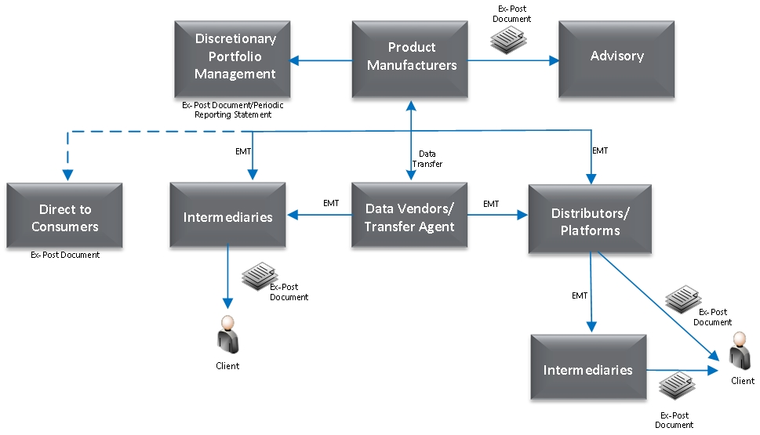

*Ex-Post Fund Manufacturer data exchange*

### Method of Ex-Post Data Exchange

ESMA’s Investor Protection Q&A suggest that MiFID Firms are expected to liaise with Fund Manufacturers to obtain the data necessary in order for them to comply with their obligation to provide their clients with Ex-Ante and Ex-Post Costs and Charges disclosures. For this reason, the European Working Grouphas created a European MiFID Template (“EMT”) in an effort to influence the Asset Management industry to adopt a standardised approach for the exchange of data, including fund costs and charges at share class level. See Chapter 10 for further details on the EMT.

Fund Manufacturers might choose to distribute the EMT directly to MiFID Firms or may wish to engage the services of various data exchange vendors who will co-ordinate the process on their behalf.

### Timing of Ex-Post disclosures

* TISA notes that the only mandatory requirement is to generate Ex-Post on an annual basis. However as provided in the MiFID II Investor Protection Q&A firms can chose in addition to send Ex-Post on a quarterly basis.
* Firms may choose to follow a uniform 12 months calculation period for Ex-Post generation for all its clients. For example, if a firm generates an Annual Ex-Post statement every year on 30 June for all its clients
* Alternatively firms may customise the Annual Ex-Post calculation period for each client or client categories separately. For example- one set of clients can receive the annual Ex-Post statements for an April to March period whilst another set of clients can receive for the statements for a Jan to Dec period.

**For existing clients before 3 January 2018, when will the first Ex-Post report be generated?**

* For firms preferring to use the 12 months period based on a calendar year of January to December:
* The first Ex-Post statements should cover the calculation period for the 12 months from 3 January 2018 through 2 January 2019. Ex-Post statements can be sent out to the client by April 2019 at the latest or earlier along with other periodic reports to the client.
* For firms preferring to use a different 12 months period - say for example 12 months ending in March:
* The first Ex -Post statement should cover the calculation period of 3 months from 3 January 2018 to March 31 2018.
* Thereafter the Annual Ex-Post statement will cover the calculation period of 12 months from April 2018 to March 2019 of the next year.

Note: if the first Ex-Post calculation period is very insignificant say it covers less than 3 months; an alternative option is to generate a combined first Ex-Post report for more than 12 months.

**TISA considered ex post disclosure requirements during 2018 in the context of ESMA Investor Protection Q & A, Question 21. TISA’s view is that the ongoing MiFID II relationship referred to in the Answer to Q21 commences on 3rd January, 2018, when MiFID II is implemented. Therefore, firms can select 1st January as the Annual anniversary date of the relevant service commencing with the client. However, if firms wish to provide an interim report during 2018, (for example, to enable future annual reporting to be on say a March, or April, or other date) they should provide costs and charges for the period in 2018 to the date of the report and either annualize to show a full year effect, if that will not be misleading, or show the figures solely for the 2018 period and state that there are no comparable figures for 2017. Firms should explain why this is the case, such as that data on a MiFID II compliant basis is not available prior to 2018, and that reports for subsequent periods will have such costs and charges figures.**

**For new clients joining from 2018 onwards, when will the first Ex-Post report be generated?**

* This again depends on the Ex-Post 12 months calculation period the firm wishes to follow as already explained above. For example if a client joins on 1 March 2018 and the firms follows a July to June annual Ex-Post calculation period
* The first Ex-Post statement will be generated from 1 March 2018 to 30 June 2018
* Subsequent Ex-Post statements will be for 12 months from 1 July 2018 to 30 June 2019.

Note: if the first Ex-Post calculation period is very insignificant say it covers less than 3 months, an alternative option is to generate a combined 1st Ex Post report for more than 12 months.

**Ex-Post situation when a client leaves, when should the Ex-Post report be generated?**

* Case 1: Client joins and leaves within 1 year i.e., the total time spent is less than 12 months - for example the client joins on 1 April 2018 and leaves on 30 September 2018:
* The Ex-Post statement will be for the period 6 months from 1 April 2018 to 30 Sep 2018.
* TISA recommends generation of Ex-Post statements for the above 6 months be done at the time when client leaves, where this is practicable. We recognize that during 2018 this might not be possible to do when the client leaves. In these circumstances, and as an alternative firms can also chose to generate the Ex-Post report later along with the Ex-Post generation for all its existing clients.
* Case 2: Client leaves after receiving its last Annual Ex-Post report. For example the client receives the last Annual Ex-Post statement for the 12 months ended December 2018 and the client then leaves in April 2019.
* The Ex-Post report will be for the period Jan 2019 to April 2019 i.e. 4 months
* TISA recommends generation of the Ex-Post report for the above 4 months be done at the time when client leaves, where this is practicable. We recognize that during 2018 this might not be possible to do when the client leaves. In these circumstances, and as an alternative firms can also chose to generate the Ex-Post report later along with the Ex-Post generation for all its existing clients.

### How should the Manufacturer communicate one-off costs to distributors?

If the Fund Manufacturer has the ability to charge a fee but does not charge it in practice, the Fund Manufacturer will know the actual entry cost to disclose the costs incurred to the distributor.

If one off costs of entering the fund are charged by the Fund Manufacturer and the distributor rebates this to the investor, the actual one off cost will not be known to the Fund Manufacturer so the full one off charge should be disclosed as the cost to the distributor.

## Ex-Post Reporting Disclosures for Distributors

### Content/Template

It is a mandatory requirement to show the aggregated totals of Product, Service and any third-party payments received. These figures must be shown as a percentage and monetary amount. As mentioned in the Ex-Ante chapter of this document, ESMAs Investor Protection Q&A Q.13 offers guidance on the aggregation of the charges summary. Firms should at least provide clients with the following level of information:

• Investment services and/or ancillary services

• Third party payments received by the investment firm

• Financial instruments

Please see Sections 3.2.2, 3.2.3 and 3.2.4 for details of these pre-defined categories of information that must be provided.

As both ESMA and the FCA have indicated[[24]](#footnote-25) that they do not intend to suggest a prescriptive format (i.e. format, colour, font size etc.) for the disclosure medium, TISA has developed a strawman template and guidance for Fund Manufacturers and relevant MiFID service providers.

This template can be rendered on web pages, emailed, hyperlinked as .pdf documents, and/or provided in hard copy format to clients.

Distributors will use the Fund Manufacturers product costs from the EMT together with the information received from the Fund Manufacturer and/or Transfer Agent on service costs to create a personalised statement to the end investor. It is the responsibility of the Fund Manufacturer to provide the generic product costs and the distributor to combine the service level costs where applicable to provide a personalised summary.

***Disclaimer: this data / these figures are not representative of any specific portfolio manager and are solely for illustration purposes. Growth rates are for illustrative purposes, as are holding periods. Firms should use growth rates and holding periods appropriate to the funds or portfolios described.***

### Ex-Post Fund Manufacturer Template

The following is an example Ex-Post cost and charges disclosure template for a Fund Manufacturer. Fund Manufacturers may use this to service commercial requests from direct clients to provide a personalised statement of fund cost and charges.

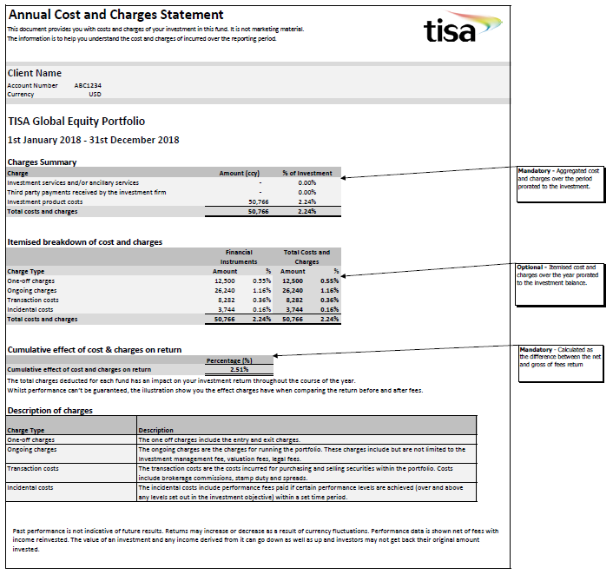

### Ex-Post Fund Distributor Template

This is an example Ex-Post cost and charges disclosure template for a Distributor. Distributors would receive the EMT product costs from product manufacturers to which they would add their own service costs to provide the end investor with a personalised statement.

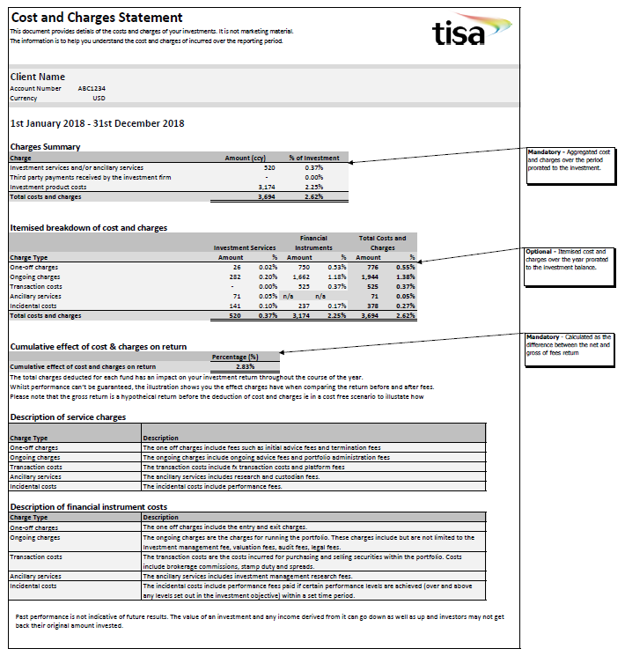

### Ex-Post Funds Cost and Charges Disclosure – Advisory Portfolio Template

This is an example Ex-Post cost and charges disclosure template for an Advisory portfolio.

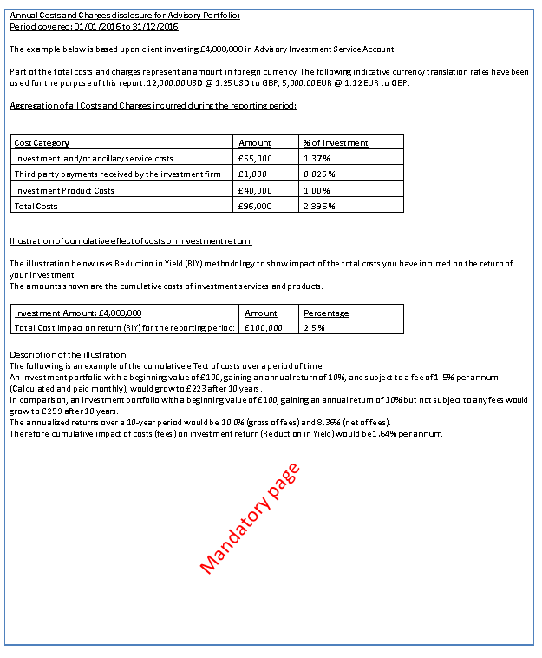

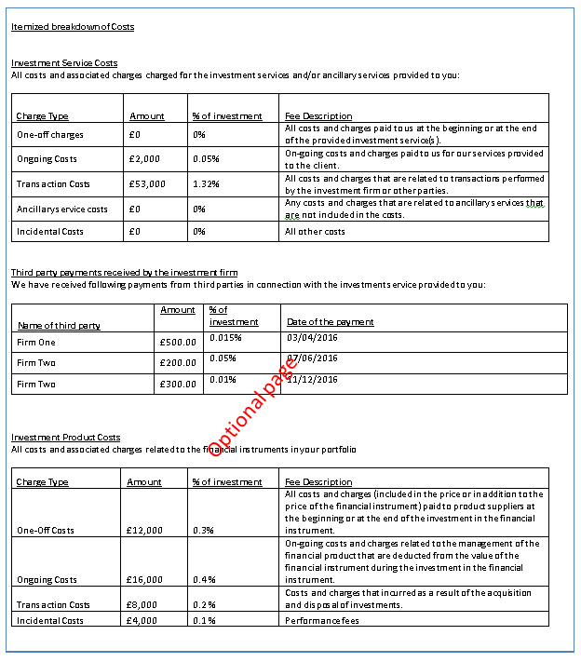

### Third-party payments received by the investment firm

“Third Party payments received by investment firms or other parties in connection with the investment service provided to a client shall be itemised separately and the aggregated costs and charges shall be totalled and expressed both as a cash amount and as a percentage”

Third party payments received by firms in connection with the investment service shall be regarded as part of the cost of the service and identified separately (i.e. it should be clear to the client what part of the costs paid are rebated to the firm providing the investment service). This typically relates to retrocession or commission payments received by the investment firm. Care must be taken not to double-count any costs in both the third-party cost category as well as the product cost bucket.

For example: A client that has been charged 0.20% AMC, and 0.05% of this is routinely given back to the intermediary as a retrocession (i.e. a 3rd party cost). The Ex-Post disclosure should reduce the cost to 0.15% and the 0.05% noted as a third party payment.

## Disclosure of zero cost where no cost or charge incurred

The ESMA Investor Protection Q&A, Question 20, raised the question as to whether zero costs should be reported.

TISA recommends that disclosures should be made such that they are true, fair and not misleading. Firms should thus consider whether recording zero in a cost line is appropriate. For example, reporting zero in respect of performance fees might be misleading if performance fees are not charged, as it would imply that they might be.

## Fund of Funds and Multi-Strategy Portfolio Reporting

### Sourcing cost & charges data for Fund of Funds

The calculation of ongoing charges for the UCITS KIID requires a look-through to take account of the underlying funds’ ongoing charges. Similarly cost figures for PRIIPs are calculated on a look-through basis to take account of the costs arising in underlying PRIIPs. Therefore ongoing charges reported in the EMT will already take account of the costs of the underlying funds in a find of funds structure.

### Look-through materiality for multi-strategy portfolios

To the extent that a look-through is required for costs and charges information under MiFID II, we feel it appropriate for members to read across the proposed guidance from PS17/20[[25]](#footnote-26) COBS 19.8.8G(2) in relation to materiality.

*“A firm, when seeking information about transaction costs or administration charges, should consider the materiality of that information to the calculation of costs and charges overall for each arrangement, in particular the degree to which it is necessary to look through to transactions in underlying investments in order to arrive at a fair assessment of the costs or charges of each arrangement.*

In doing so however, firm’s should be able to explain and evidence how they have assessed materiality and the basis on which (if applicable) a conclusion has been reached that costs and charges information was not material. Firms should consider where such an assessment has been made and it has been concluded that such costs and charges were not material to the particular situation that this should be included in the cost and charges disclosures in order to enable the investor to obtain more detailed information.

Such an assessment could be based on the size of the position within that portfolio, where for a holding that has a weight of less than 0.4% of the NAV, the average costs and charges of the remaining positions is be used as an approximation. The sum of these non-material positions should not in aggregate exceed 2% of the NAV.

Please note the materiality threshold has only been considered in the context of strategies that require a look through to underlying investments to obtain cost and charges information. Any materiality thresholds and guidance at a security level for transaction costs is being considered as part of the implicit transaction costs analysis being conducted by the Investment Association.

### What do we do in the case of non-EEA funds that are not obligated to provide MiFID compliant data?

TISA recognises that where third party investments are made, not all of the underlying managers may be bound by MiFID II such as US or Asian Fund Managers. In this situation Investment Firms should seek to obtain appropriate cost information from all MIFID and non-MIFID Fund Manufacturers.

Where investment firms only receive an all-in cost indicator, the investment firm should confirm with the third party manager whether this figure includes transaction costs and adheres to the methodology prescribed by MiFID II. If this figure excludes transaction costs firms should request these are provided separately, make an assessment of materiality as mentioned in the previous section or make a reasonable estimate of this cost and disclose any assumptions.

Question 11 of the ESMA Investor Protection Q&A supports this guidance what an investment firm should do when they are unable to obtain the relevant data from the Manufacturer.

*“When the investment firm is not able to obtain the relevant data from the manufacturer, the investment firm should first assess whether it can provide its clients with adequate information on the total costs and charges of the financial instrument and the investment service. ESMA would expect investment firms to base these calculations on the methodology prescribed in the PRIIPs RTS[[26]](#footnote-27). It is essential that the investment firm has assured itself that it can make a reasonable and sufficiently accurate estimate of the total costs of the financial instrument. If this is the case, an investment firm may use this estimate to calculate the ex-ante and ex-post figures on costs and charges.”*

### Cumulative Effect of cost and charges on return

Investment firms shall provide their clients with an illustration showing the cumulative effect of costs on return when providing investment services. On an Ex-Post basis this should be the actual realised net return compared to the return before the deduction of fees. The illustration can take the form of a graph, table or narrative and should meet the following requirements;

(a) The illustration shows the effect of the overall costs and charges on the return of the investment;

(b) The illustration shows any anticipated spikes or fluctuations in the costs; and

(c) The illustration is accompanied by a description of the illustration.

Investment firms could use a table such as the below to illustrate the effect cost and charges have on return.

|  |  |  |
| --- | --- | --- |
| **Cumulative effect of cost and charges on return of investment** | |  |
|  | **Percentage (%)** | **Amount (Ccy)** |
| Return before the deduction of cost and charges (gross) | 7.56% | £756 |
| Return after the deduction of cost & charges (net) | 5.28% | £528 |
| Cumulative effect of cost & charges (Difference) | **2.28%** | **£228** |

Alternatively Investment Firms could use a graph to illustrate the effect fees have had on the return throughout the last year, such as the below.

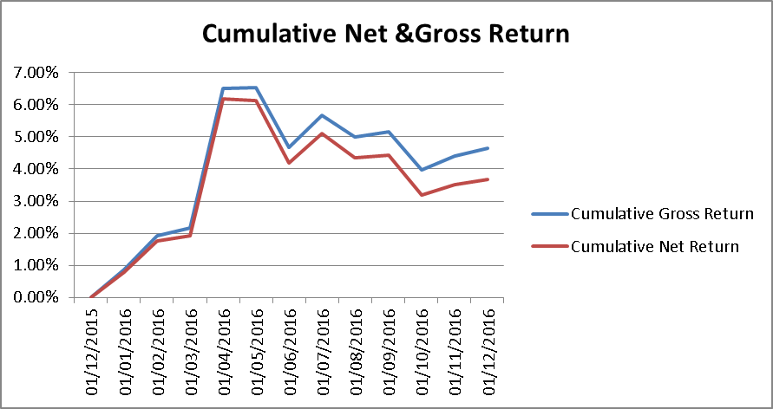

For more information on the cumulative effect of costs & charges on return, the methodology and a workbook example please see Chapter 9.

## Ex-Post Discretionary Portfolio Reporting: Methods of Reporting

### TISA Discretionary Investment Management Template

This is an example Ex-Post costs & charges disclosure template of how firms could present the costs & charges of running the segregated portfolio for the client. Other options may be to include the costs & charges in the periodic reporting or the client may elect to receive the EMT for onwards cost and charges calculation to end investors.

### 

It should be noted that the cumulative effect should be shown on a cumulative basis, since the start of the MiFID II relationship. That is, roll the costs up and the impact, such that after two years, the report shows two years costs and the effect on return.

### Article 60 Reporting obligations in respect of portfolio management

Under Article 60 of the MiFID II Delegated Regulation, investment firms providing clients with the service of portfolio management (such as segregated mandates) are required to provide clients with a portfolio statement on a periodic basis, which includes relevant information for the client including costs of the portfolio.

Art. 60(2)(d) - the total amount of fees and charges incurred during the reporting period, itemising at least total management fees and total costs associated with execution, and including, where relevant, a statement that a more detailed breakdown will be provided on request;

The above requirement was included in MiFID I and exists as a UK regulatory requirement under the existing COBS 16 Annex 2R(4) - therefore investment firms already have to comply with the above requirement.

ESMA has not subjected the disclosure requirement under Art. 60 (2)(d) to the cost disclosure requirements of Art. 50 of the MiFID II Delegated Regulation. Therefore, investment firms are not required to amend the Art. 60(2)(d) costs disclosure in the periodic portfolio statements provided to clients on a monthly, quarterly, or annual basis.

Firms should note that, in addition, they should provide the MiFID II Article 50 costs and charges statement[[27]](#footnote-28) to clients on an annual basis (including the disclosure of both explicit and implicit transaction costs of the portfolio).

### FCA institutional disclosure reporting[[28]](#footnote-29)

In addition to the MiFID II costs and charges requirements, the FCA has stated in its Asset Management Market Study (Final Report) that they support consistent and standardised disclosure of costs and charges to institutional investors. The FCA recommends that both industry and investor representatives agree a standardised template of costs and charges and they have asked an independent person to convene a group of relevant stakeholders to develop this further. Following this, the FCA intends to work with these stakeholders to consider whether any other actions are necessary to ensure that institutional investors get the information they need to make effective decisions.[[29]](#footnote-30)

The Institutional Disclosure Working Group (IDWG) reported their recommendations to the FCA in the summer of 2018.[[30]](#footnote-31) The FCA accepted them and supported the launch of the Cost Transparency Initiative (CTI) in November 2018.[[31]](#footnote-32)

The CTI is developing templates for costs reporting[[32]](#footnote-33) and firms should consider these in developing reports for institutional clients.

It should be noted that the draft templates to date on their own do not fully meet the requirements of MiFID II, as they do not show the total costs as a single figure, or a percentage, nor show the cumulative effect of costs and charges on returns, as required by the Directive and Delegated Regulation.[[33]](#footnote-34)

# **Guide to categorising cost and charges**

This section details the types of Investment service and financial instruments costs that would be classified into one-off costs, ongoing charges, transaction costs, ancillary services and incidental costs.

For further information please refer to Annex II of the MiFID II Delegated Regulation as per Sections 3.2.2 and 3.2.3.

### What information can be sourced from the administrators?

The Ongoing Charges Figure (OCF) or the Total Expense Ratio (TER) excluding performance fees can be used as the building blocks for the ongoing product charges in the costs table and the performance fees separately shown in incidental costs.

### One-off charges

One-off costs are the costs and charges paid to the investment firm at the beginning or at the end of the provided investment service(s), for example entry or exit fees.

### What charges are contained in the ongoing charges?

Examples of such fees that are in included in the calculation include but are not limited to;

* Administration Fees
* Audit Fees
* Custodian Fees
* Directors Fees
* Formation Fees
* Guarantor Fees
* Legal Fees
* Investment Management Fees
* Registration Fees
* Risk Transfer Fees
* Service Manager Fees
* Sub Registrar Fees

In addition, firms may need to source the following charges not currently included in the OCF and TER calculations;

* Trading Stock Borrow Fees
* Trading Swap Financing Fees
* Research costs

Ongoing Charges should be calculated as the sum of fees over the previous 12 months divided by the share class NAV over the same period.

Administrators typically provide the OCF/TER expenses breakdown on an annual basis; however some firms may wish to request an estimated figure more frequently to monitor costs for Ex-Ante disclosures, for Article 60 periodic reporting and being able to attribute fees to part periods or periods where performance fees were charged.

### Incidental Costs

These costs include performance fees and carried interests that may be calculated by the administrator separately from the Ongoing Charges Figure (OCF).

Incidental costs should be calculated as the sum of performance fees and/or carried interest divided by the share class NAV over the same period.

Firms should capture performance fees at least annually or in line with the dissemination of the EMT or cost and charges disclosure. If performance fees are recorded more frequently it would enable firms to distribute the EMT intra-year as accurate performance fees for the part years can be combined to show the total performance fees accrued by the average investor through that period.

### Transaction Costs

Transaction costs include both explicit and implicit costs of buying underlying securities within the portfolio. Some of these transaction costs are listed below for reference.

* Brokerage Commissions
* Exchange Fees
* Clearing Charges
* Exchange Clearing
* Exchange Execution
* PTM Levy
* Stamp Duty
* Execution Slippage Cost/Spreads

**Definition of transaction costs**

Transaction costs represent the trading cost of the portfolio, for the acquisition and disposal of the investments. This fee includes both the explicit and implicit costs. The explicit costs are those fees paid to facilitate or undertake the actual trading, for example to a trading desk or broker. Implicit costs are the difference in the prevailing price of the investment when the trade was first sent for execution and the price actually paid for the investment. It therefore measures the financial impact of the ‘delay’ between putting in a trade and the trade being executed. This is known as the ‘arrival price’ methodology.

**Why a transaction cost can be negative**

Although explicit transaction costs will always be positive, the methodology prescribed by the regulator to calculate the transaction costs can include element that are negative, or in other words, seen as a benefit or gain to the end investor.

These include firstly, the impact of dilution levies, including the effects of swing pricing.

Dilution levies are where a fund may charge a separate fee to an investor buying or selling the fund for the transaction costs that will be incurred by the fund (either having to purchase additional investments to ensure the fund is fully investment or selling assets from the portfolio to pay the investor in the case of a sale). Swing pricing is similar in concept but is where the manufacturer changes (or swings) the purchase/sale price of the fund on the basis of the overall flow of money into or out of the fund on that day to factor in any transaction costs that will occur as a result of the flow.

These dilution levies can be taken off of the transaction costs as they ‘compensate’ the existing and ongoing investors in the fund for any transaction costs incurred by the fund by new investors/sellers.

An oddity of the regulation is that the swing price is not seen as a ‘one off’ cost for the investors purchasing or selling the fund (an explicit separately charged dilution levy would be seen as a one off cost) – as there is only one price the fund can be bought or sold on.

The ‘arrival price’ methodology for calculating the implicit costs (explained above) can result in negative costs, for example where the prevailing price when a trade to purchase an investment is sent (e.g. £100) being higher than the price the trade was executed at (e.g. £99). In this example the ‘cost’ would be -£1.

In some cases this can lead to the overall transaction cost, under the methodology prescribed, being negative.

**TISA advice on ex-ante transaction cost reporting**

From January 3rd 2018, ESMA recommends all PRIIP manufacturers use the full arrival price methodology to calculate their transaction costs, the expectation being that this would only lead to small negative transaction costs in some limited cases.

The pre-sale (or ex-ante) transaction costs need to be calculated as well and should be an average of the last 3 years’ worth of the fund’s transaction costs. Many manufacturers do not have historical data for the prevailing price of their investment when the trade was sent (only recording the price that was actually paid/received for the investment).

In these cases the regulation allows the previous day’s close (or that day’s opening price) to used in lieu of the actual prevailing price when the trade was placed. This can lead to a very large market movement being introduced into the calculation (either positive or negative) and unreasonably high or low transaction fees but that are a result of following accepted methodologies prescribed by the regulatory body (ESMA).

Full arrival price methodology should therefore be used where possible (we are aware there is an interpretation that UCITs, NURs and other vehicles that have a derogation until 2020 can use the so called ½ spread methodology outlined below).

However, in any case, the Q&A paper published by ESMA includes the following paragraph

*‘An investment firm may assess that the costs involved in calculating the transaction costs using the method provided in paragraphs 12 to 20 of Annex VI of the PRIIPs RTS are disproportionate compared to their significance. In such cases, the firm may use an alternative approach (e.g. the method provided for in paragraphs 21 to 23 of the Annex VI of the PRIIPs RTS) to calculate transaction costs, provided that it identifies the actual transaction costs associated with the transaction, and that it clearly discloses to clients the basis on which transaction costs have been calculated.’*

The Q&A is in relation to ex-post information, but we believe the principle can also be applied to ex-ante disclosures, and therefore advise, that where the methodology results in a value that it is not fair, clear and not misleading (in that it cannot be reasonably be expected to be an accurate estimate of what the investor would experience) that the manufacturer should use a different methodology. In all cases, firms should document the reasons for their decisions.

Potential options include: -

1. The so called ‘New fund’ methodology outlined in the PRIIPs RTS (annex VI paragraphs 21-23). This uses the estimated portfolio turnover for the period multiplied by an estimate of the ½ spread for the relevant asset class.
2. Using a combination of the arrival price methodology for those times where the manufacturer has full data on the prevailing price and the ½ spread methodology outlined above.
3. To apply some validation to the inputs created by using previous close or opening prices (used as substitutes for the actual prevailing price) and removing those values that are unrealistic/unreasonable.
4. To calculate the actual ½ spreads on a trade by trade basis (where possible and used estimates for the rest).
5. Ignore the implicit part of the calculation (if unreasonable) and report the explicit costs and impact of dilution levy only.

**In all cases the reported value for transaction cost should be one the manufacturer believes to be a true, fair and not misleading representation of the actual costs that an end investor might reasonable incur going forward.**

Transaction costs should be calculated as the sum of costs divided by the share class NAV over the same period.

FX hedged share classes will also have specific costs attributed to them from buying and selling FX forwards.

### Service Costs

Such service costs associated with Execution-Only services include but are not limited to:

* FX charges
* Dealing charges
* Multi-currency FX trade (i.e., commission from sub/red in other class currency)
* Dilution Levy
* Wrapper costs
* Exit and Entry charges
* Rebates and Retrocessions
* Switching costs
* Bank transfer fees

### Example Breakdown of detailed costs and charges for a “fund”

The table below provides an example of how a variety of types of charges can be classified, i.e., Service cost or product cost. These are based on TISA assumptions.

***Example Breakdown of detailed costs and charges for a “fund”***

|  |  |
| --- | --- |
| **Charge Type** | **TISA Classification** |
| **Charges related to investment service** |  |
| **One-off Fees/Costs** | **Service Costs – One-off charges** |
| Administration Fees/Costs | Service Costs – One-off charges |
| Initial Advice Fee | Service Costs – One-off charges |
| Initial Discussion Fee | Service Costs – One-off charges |
| Deposit fees | Service Costs – One-off charges |
| Termination fees | Service Costs – One-off charges |
| **Transaction Fees/Costs** | **Service Costs – Transaction Costs** |
| FX Forward Costs | Service Costs – Transaction Costs |
| FX Spot Costs | Service Costs – Transaction Costs |
| Interest Rate Swap Costs | Product Costs – Transaction Costs |
| Platform Fee | Service Costs – Transaction Costs |
| **On-going Fees/Costs** | **Service Costs – Ongoing Costs** |
| ISA Administration Fee | Service Costs – Ongoing Costs |
| Management Fee | Service Costs – Ongoing Costs |
| Ongoing Advice Fee | Service Costs – Ongoing Costs |
| Leveraged Lending Cost | Service Costs – Ongoing Costs |
| Tax Reporting Fee | Service Costs – Ongoing Costs |
| Trust Fee | Service Costs – Ongoing Costs |
| **Ancillary Costs** | **Service Costs – Ancillary Costs** |
| Custody Fee | Service Costs – Ancillary Costs |
| Research Costs | Service Costs – Ancillary Costs |
| **Incidental Costs** | **Service Costs – Incidental Costs** |
| Performance Fees | Service Costs – Incidental Costs |
| **Charges related to financial instrument** |  |
| **One-off Fees/Costs** | **Product Costs – One-off Costs** |
| Fund Initial Charge | Product Costs – One-off Costs |
| Fund Redemption Charge | Product Costs – One-off Costs |
| Fund Switching Charge | Product Costs – One-off Costs |
| **Transaction Fees/Costs** | **Product Costs – Transaction Costs** |
| Market Commission | Product Costs – Transaction Costs |
| Exchange Fees | Product Costs – Transaction Costs |
| Clearing Charges | Product Costs – Transaction Costs |
| Futures clearing | Product Costs – Transaction Costs |
| Exchange Clearing | Product Costs – Transaction Costs |
| Exchange Execution | Product Costs – Transaction Costs |
| PTM Levy | Product Costs – Transaction Costs |
| Fund Dilution Levy | Product Costs – Transaction Costs |
| Implicit Spread Costs | Product Costs – Transaction Costs |
| Stamp Duty | Product Costs – Transaction Costs |
| **On-going Fees/Costs** | **Product Costs – Ongoing Costs** |
| Audit Fees | Product Costs – Ongoing Costs |
| Custodian Fees | Product Costs – Ongoing Costs |
| Directors Fees | Product Costs – Ongoing Costs |
| Formation Fees | Product Costs – Ongoing Costs |
| Guarantor Fees | Product Costs – Ongoing Costs |
| Legal Fees | Product Costs – Ongoing Costs |
| Management Fees | Product Costs – Ongoing Costs |
| Other Fees | Product Costs – Ongoing Costs |
| Registration Fees | Product Costs – Ongoing Costs |
| Risk Transfer Fees | Product Costs – Ongoing Costs |
| Service Manager Fees | Product Costs – Ongoing Costs |
| Sub Registrar Fees | Product Costs – Ongoing Costs |
| Trading Interest Fees | Product Costs – Ongoing Costs |
| Trading Stock Borrow Fees | Product Costs – Ongoing Costs |
| Trading Swap Financing Fees | Product Costs – Ongoing Costs |
| Trading Other Fees | Product Costs – Ongoing Costs |
| Research costs | Product Costs – Ongoing Costs |
| **Incidental Costs** | **Product Costs – Incidental Costs** |
| Performance Fees | Product Costs – Incidental Costs |
| Carried interest | Product Costs – Incidental Costs |

# **Calculation of end investor costs for Ex-Ante and Ex-Post disclosure**

This section aims to provide guidance on the best practice for the calculation of the end investors’ costs that need to be displayed in both the pre-sale and annual report that a distributor is required to supply under MiFID II.

Firstly the annualised costs for the products need to be collected, in the standardised fee ‘buckets’ defined by MiFID: One-off costs, Ongoing costs, Transaction fees and Performance fees (or carried interest).

For firms that have the ability, calculating end investor fees on a daily basis is the most accurate; however, undertaking the calculation monthly would be sufficient in our opinion.

The period fees can be calculated by the following steps:

* Taking the opening balance for each product at the beginning of the period.
  + This is simply the amount the client had invested in the product at the time and can be calculated by taking the product price per unit (e.g. NAV) and multiplying by the number of units held, or in the case or Ex-Ante projection using an assumed growth rate.
* De-annualising the relevant ongoing charge, transaction fee and performance fee charged by the product.
  + This can be done by taking the annual fee and raising to the power of 1/(number of periods in a year) – e.g. 1/12 if using monthly periods or 1/(# days end investor portfolio valued in the year) if using daily periods.
* Multiplying the opening period balance by the de-annualised fee will give the relevant charge for the period.
* Repeating this process for each period, and for each product will show the total product costs throughout the year in currency terms.

The method for calculating the costs in percentage terms for an Ex-Ante report using a single lump sum figure is to take the relevant cost for the period and divide by the initial amount. If the report is for Ex-Ante regular savings or Ex-Post then use the average account balance over the period as the divisor.

The calculation needs to take into account significant cash flows e.g. the end investor injecting additional monies into the account or making any withdrawals. Any entry or exit costs need to be calculated at the time of the inflow or withdrawal and then the purchase/sale will affect the opening balance held in the product for the next period’s fee calculation.

An interactive example modelled in a Microsoft Excel ® spreadsheet has been provided to help illustrate the calculations.



# **Cumulative Effect of Costs on Return for Ex-Post Reporting**

Many investment firms will be employing systems that calculate performance before and after fees, valuing portfolios on a daily basis, thereby adjusting for daily cash flows and daily market movements. Using the daily data to calculate the average capital employed will account most accurately for inflows and outflows and reduce distortions. It will also help to ensure that the impact of initial fees for example on the performance is proportionate to the actual value of the funds at that point. Using monthly valuation data would be sufficient if this is not possible however the level of difference will depend on the volume and timing of inflows, outflows and fees.

Chapter 4 referred to reporting the cumulative effect of costs on the return for Ex-Ante disclosures where the Reduction in Yield from PRIIPs is applied to determine the impact of fees by projecting forward the notional value by the illustration growth rate without any costs, and reducing this by the actual growth. For Ex-Post reporting the actual realised net return should be compared with the return before the deduction of fees.

* This can be summarized as: Calculate the individual fee components and sum the total fees for the day. This can be referenced in column AV of the embedded spreadsheet provided in Chapter 8.
* Sum the net value of the investments in the portfolio (after the deduction of fees)
* Calculate the gross value of the portfolio (cost free scenario) by adding back the total fees to the net value in points 1 and 2. GIPS standards should be adopted if available and appropriate.
* Calculate the gross return by dividing the calculated gross portfolio value by the previous (T-1) net value of the portfolio.
* Calculate the net return by dividing the net valuation of the portfolio value by the previous (T-1) net value adjusted for flows.
* The daily or monthly gross and net of fee returns should then be geometrically linked to generate the compound cumulative net and gross returns over the period.

* The difference between the gross and net return equals the cumulative effect fees have had on the investment return.
* Note that the example provided in the spreadsheet utilises “start of day” accounting for performance calculations, however this is not prescriptive, and firms may adopt other performance measurement accounting policies. Where daily calculations are used, this is not expected to give significant impacts, however for monthly based calculations the difference will be more apparent where there are significant investment additions or withdrawals.

When providing the client Ex-Post with information on total costs and charges, a firm can for instance decide to show the historical costs, and simultaneously provide the client with a forward-looking illustration with regard to expected costs. In this case, the firm can show the historical costs that show a spike, for instance because of entry costs, and future expected costs based on the firm’s expectations (including anticipated spikes and fluctuations).

If the Ex-Post illustration takes into account only historical data, the firm has to account for realised spikes and fluctuations in costs. However, since these data are historical, there are no ‘anticipated’ spikes.

# **European MIFID Template (EMT)**

## About the EMT

The requirements for distributors to disclose to their clients, detailed Ex-Ante and Ex-Post illustrations, raises new challenges for the flow of information across the entire distribution chain. Many of the costs that need to be reported, will not be readily available to the end distributor. In such cases, the distributor will need to ensure that they coordinate with the product manufacturer; to source any outstanding product related costs. This requirement is clearly indicated by the ESMA Investor Protection Q&As.

*Q - “How does the investment firm obtain access to the relevant data for a financial instrument…?”*

A “...The investment firm would be expected to liaise with the manufacturer of these instruments to obtain the relevant data, if the data has not already been made publicly available…”[[34]](#endnote-2)

To standardise the flow of such information, the EMT has been created. This template is the culmination of inputs from various trade bodies, product manufacturers and distributors, from across Europe. The template looks to normalise the exchange of both target market and cost and charges data, between the product manufacturer and end distributor, by dictating the naming, formatting and codification of the fields that need to be provided. Such standardisation is crucial for producing consistent, machine-readable files. This in turn, allows distributors to anticipate the data being provided and develop their systems accordingly.

The EMT requires the provision of product related costs, for the calculation on both an Ex-Ante and Ex-Post basis. Each cost field is labelled with a prefixed containing either “one-off”, “ongoing”, “transaction” or “incidental”. These categories are consistent with the product costs buckets, laid out within the annexes to the commission delegated regulation and can be used should a client request a granular breakdown of costs and charges. A distributor should use the product costs, from within the EMT, as a basis for their reporting. These should then be combined, with their own service level costs.

TISA recognises the need for a consistent approach to the exchange of MiFID costs and charges data and encourages its members to adopt the standard laid out within the EMT. Product manufacturers should make the EMT available to their distributors. Should the end distribution point of their product be unknown, they should pass this to the first known point within their distributor chain. TISA also encourages product manufacturers to make the EMT available to market data vendors. This will develop the centralisation of MiFID costs and charges data, making it more accessible to the end distributors.

## Completing the Ex post section of EMT

In order to help firms with completing the Ex-Post section of the EMT v1 a group  of asset managers and distributors came together to suggest a best practice approach – referred to as the “Blackfriars Analysis” we have reproduced the analysis they published below

### Introduction

This analysis and suggested practice focuses on the preferred methodologies for use in completing the Ex-post section of the EMT v1. The group that have authored this document came together in an effort to bring some clarity to the output of various industry discussions where a proliferation of different standards and methodologies were being considered by manufacturers who remained genuinely confused as to how they should populate their EMT as a result of a lack of consensus in the various EWG meetings.

This is particularly challenging for firms who distribute cross border into multiple different jurisdictions, particularly given the current lack of consensus across Europe in the area of cost disclosure

Paramount was the concern that without something approaching an industry standard, the counterparties that rely on this data would receive multiple versions of the truth, all following different methodologies, reducing the effectiveness of the EMT and removing the benefits that this ubiquitous template brings to all involved.

In undertaking our analysis we considered that most manufacturers would create an EMT on either a monthly or quarterly basis. However we are also aware that in some jurisdictions the local regulator has agreed that figures can be based on the last audited set of fund data and only has to be refreshed annually. Clearly for firms only distributing within a local market the overriding consideration will be the local code of practice.

We also wanted to ensure that the data the EMT would carry was as accurate as reasonably possible whilst retaining the principal that “close is close enough”. Again some local regulators have given clear views on this and so manufacturers only offering products within a local domestic market already have a set of standards to follow – where we are aware of these we have commented below.

The group was particularly challenged in trying to create a suggested best practice by the constraints enforced by the Beginning/End date fields in the ex-post section of EMT v1 and their varying impact when applied to the different cost types listed in this area of the template, particularly when costs might vary over the period covered by these dates.

1. **Ongoing costs**

The majority of manufacturers are considering covering a 12 month period in their beginning/end date fields, however this has a particular impact in the very common current scenario of a fund or share-class changing its AMC during the period of the report.

* 1. Using a slightly exaggerated scenario, if a fund had an AMC of 1% at the start of a 12 month period and reduced it to 0.5% exactly half way through the period it would be inaccurate to use an average of 0.75% for the entire 12 months when using this data for any client that exited that particular fund during that time, with the inaccuracy at its most pronounced if the exit occurred shortly after the rate change. Similarly if a client first invested in that fund as a result of the rate reduction it would also be very inaccurate to use the average rate of 0.75%.
  2. Our conclusion was that the wider the date range used in the ex-post section the greater the level of inaccuracy, therefore we should limit the range to a month/quarter depending on the frequency of dispatch that the manufacturer deployed for its EMT.
  3. In calculating the appropriate AMC we had the following suggestions, bearing in mind the principal of “close is close enough” and that the way the EMT v1 is constructed means there is not a solution that allows a precisely accurate population of this field
* A daily average for the period should be used, particularly if the EMT is issued on a monthly basis, however we recognise that this could be challenging for firms to implement.
* If the amendment occurs at or near the middle of the month/period a simple average of the old and new rate could be populated in this field
* If the amendment occurred towards the end of the month/period the old rate could be used at it would only be inaccurate for a small number of days
* If the amendment occurred near the start of the month then the new rate could be used, again as this would only be inaccurate for a small number of days
  1. To illustrate how this might work, using a scenario of an AMC change from 0.8% to 0.6% occurring on the 10th July.
* In the 6 monthly EMTs published for January through to June, field 08050 would be populated with 0.8%
* In the EMT for July the figure would be amended using one of the options detailed above – if the daily average were used the figure would be 0.66% (or 0.658065 depending on how many d.p. are used). If the simple average were used it would be 0.7%.
* In the EMTs for August through to December, field 08050 would be populated with 0.6%
* This rule would also apply to field 08030 covering Ongoing Costs in this scenario
  1. *Use of data from Annual Reports:* We are aware that in some countries the regulator has made statements concerning the use of data from audited reports (in some circumstances this needs to be supplemented by the manufacturer for elements relevant under MiFID but not caught with the audited reporting methodology) for the following 12 month period. Clearly where appropriate to firms and their distribution model these local practices could/should be followed – in this scenario a 12 month data range would be appropriate. The biggest challenge in this area though remains the potential scenario of funds that reduced their AMC during the period, which could mean that the manufacturer has to consider an alternate methodology.
  2. *Multiple EMTs:* In coming to these recommendations we also considered a range of other solutions including that firms could issue two EMTs in a month, adjusting the date fields to cater for the change in rate but we felt that this was problematic not just because the dates apply to all the costs in the ex-post section, but also given the practicalities of issuing and receiving multiple EMTs.

There was a great deal of debate on the topic of was it practical for manufacturers to issue two EMTs to cover this scenario. The dates issue was one factor, if the ex-post section of the EMT carried dates from the start of the month to say the 13th of the month what did it mean for the consumption of the other cost figures, with then a second EMT being release covering the 14th to the end of the month. There was also the practical element, could the majority of manufacturers release two EMTs in this fashion in an appropriate timescale to make it feasible, the consensus was that they probably couldn’t.

* 1. *Using the ex-ante field:* We also noted that firms receiving the EMT could use the ex-ante figures for the range of ongoing costs and build a time series based off the data in this section to build a data set that could be used to calculate ex-post costs. This solution gives the most accurate figure but we recognise it places a lot of emphasis on the recipient of the EMT. We were concerned though about the standard practice of Field 00050 being a mirror of the publication date in the file header, as most EMTs are current released on a considerable lag – we felt that a repurposing of this field would assist – see our comments below in section 4.2
  2. *OGC field 08030:* The narrative in this section focuses on field 08050 but clearly as field 08030 includes the value of the AMC the same concepts apply
  3. *Distribution fee 08060:* This is another data-point that should it be amended we would expect to work in a similar fashion to fields 08030 and 08050.

1. **Transaction Costs**

The market is currently split between countries and firms using the Arrival Price mechanism and those using spreads or other estimate based methodologies either on a trade by trade or fund level.

In the case of certain fund level estimate based processes transaction costs are unlikely to vary over time, particularly in those jurisdictions when the data in the last annual report is considered an appropriate base for both ex-ante and ex-post calculations.

In other scenarios both estimate and price based transaction costs can vary over time and the question of how to use the date fields arises again

Initially, our analysis started with this data element and we were settled on the beginning/end dates covering a 12 month period and the manufacturer providing a rolling number in this field covering the 12 months encompassed by the dates, however the challenges with changing AMC/OGC rates prevented the implementation of this particular solution.

* 1. We concluded that it was still appropriate that a manufacturer provided a rolling 12 month number, on a monthly/quarterly basis, with the end date field 08100 providing the end date of the 12 monthly period. Effectively we are suggesting that field 08090 is ignored for the purposes of consuming ex-post transaction cost data.
  2. *“Annualisation”:* We recognise that recipients could take the value in each of the 12 (or fewer) EMTs that a manufacturer supplies and create their own rolling average from this data, whilst we haven’t tested the actual impact of this we feel this would reduce accuracy but not in a significantly adverse fashion
  3. *Annual audited data:* We are aware that a number of manufacturers would prefer to populate this field with audited data once per annum. It could be seen that this fits the principal of “close is close enough”, particularly as data suggests that some funds have reasonably constant transaction cost figures, but for a large section of the fund universe it would be less accurate than the model suggested, particularly in the months approaching the next annual renewal of data, enough so that it is no longer “close enough”.

1. **Performance Fees**
   1. *“Last year’s audited number”:* The most common solution that had been discussed in various industry meetings to date was that manufacturers would populate this field with the figure that applied to the previous fund year, again like with transaction costs using the “audited” actual cost levied. This solution doesn’t align well with the date parameters we had proposed using with either the OGC/AMC or Transaction costs because the figure doesn’t actually relate to the period covered in the EMT and so isn’t likely to accurately reflect the costs that the investor has experienced in this period given that its not common for markets to behave in a consistent fashion for two consecutive years.
   2. *Using Accruals:* We discussed that the published figure could be based on the accruals generated by the fund during the 12 months to the end date specified in the EMT, effectively mirroring the treatment of the date fields used in the transaction cost scenario, in the main this would reflect the costs the investor has experienced as the NAV figure of the fund is adjusted by the accrual.
   3. However, we recognised that providing a rolling 12 months of accrual may result in a negative cost figure being published as the accrual is lowered in scenarios where the fund performance is no longer exceeding the benchmark (after a period of out-performance) or otherwise falling and so might be adjusted down. Also some funds may have some complicated accrual systems for managing their accruals that might not transfer well into a scenario where costs are published.
   4. *Fulcrum Fees*: We also touched on the fulcrum fee scenario that we have seen a number of firms starting to deploy, the way that these operate we believe lend themselves to the scenario of being reported using the accruals suggestion.
   5. There only appears to be two options in this space, neither definitely providing the “perfect” result. Our preference was for the accrual driven solution covering the 12 months to the end date in the EMT, we felt in the main that this would better reflect the adjustment in the cost that the investor had experienced. We suspect that might not work for all and we recognise the challenges of measuring these costs, so a fall back would be to use the previous published figure in a scenario where the accrual would not be appropriate for whatever reason, however this could bring in a large degree of inaccuracy.
   6. *“Annualisation:”* Similar to the point made about transaction costs, if a rolling 12 month figure is provided in every file we recognise that the recipient could create an average from this data series – it has not been possible to do any testing on what impact this might have on the level of accuracy
2. **General comments**
   1. *Annualisation:* Annualised costs figures should be published for all ex-post costs regardless of the date range in the ex-post section
   2. *Reporting Date 00050:* This should be the “as at” date of the ex-ante data in the file, we understand that at present this is often the same as the publication date of the file but given it can take several days or longer to create the EMT, its more appropriate that any recipient understands at what date the data in the ex-ante section applies. Also we are aware that some manufacturers can’t publish their EMT until a month or two after the “as at” date of the data
   3. *Not Applicable:* In general the “99.99” convention is not helpful but we recognise we are bound by it in v1 of the EMT, the preference would be that this convention was removed in v2.
3. **Closed Funds**
   1. Ex-post data on a fund that has closed will be published in the EMT following the closed date of the fund – it will not be included in any further EMTs
   2. The end date in the ex-post section for any share-class which has closed will be adjusted to run to the actual close date of the fund
   3. *Ex-ante for closed funds:* It’s an anomaly of the template that ex-ante cost data is required even though the fund has closed because these fields are mandatory in EMTv1 and we understand it will trigger the validation rules of the recipient, we would like to see this anomaly resolved in EMT v2
4. **New Funds**
   1. Its not possible to immediately publish ex-post costs for a new fund/share class, therefore for the initial period, we will enter 99.99 into the EMT following the processes laid out in the existing Q&A document
   2. We would like to see a flag in the EMT v2 which identifies a fund/share-class as being a “new” fund
   3. The beginning date entered into field 08090 for a new fund/share-class will reflect the actual launch date of the fund the first time it is listed within the EMT rather than the standard one month date used for other share classes
5. **Summary of analysis** 
   1. Despite its limitations in the area of ex-post reporting we continue to see the EMT as the only method in which costs can be passed from the manufacturers to the Distributors
   2. We recommend that data relating to ex-post AMC/OGC is provided using a monthly date range using the options laid out in point 1.2. If there are concerns about the accuracy of this from recipients then perhaps the use of the ex-ante data in the manner described in 1.6 above could be explored by the Distributors in more detail
   3. We recommend that transaction costs are provided on a rolling 12 months basis to the date in field 08100
   4. We suggest that costs relating to performance fees are provided by using a rolling 12 months of accruals to the date in field 08100. However this may not work in all scenarios given the way that accruals in this area are generated so an alternative option would be to use the last audited data

1. **Thoughts on amendments for EMT v2**
   1. We’d like to see the “99.99” data-point removed as an option, even if that means that some fields that are only numeric become alpha numeric in order to allow for some form of N/A type flag
   2. It’s likely that adding a “share class status field” could help reduce the volume of “99.99” and also remove the need for the odd requirement to provide ex-ante and target market information for a fund that has closed, just because of the need to provide ex-post costs
   3. Revisiting the date fields, particularly in the ex-post section – its likely that the provision of accurate data would be improved

## The EMT V1.0 spreadsheet is provided below, with the Q&A provided by the EWG.





# **Definitions**

For the purposes of this guide, we have given the following definitions and where applicable the relevant EU regulation has been mentioned.

* **AIFM:** means ‘Alternative Investment Fund Manager’
* **Client:** means any natural or legal person to whom an investment firm provides investment or ancillary services. *Article 4 1(9) of MiFID II directive 2014/65/EU of the European Parliament and of the Council of 15 May 2014*
* **Discretionary Portfolio Management:** means managing portfolios in accordance with mandates given by clients on a discretionary client-by-client basis where such portfolios include one or more financial instruments. *Article 4 1(8) of MiFID II directive 2014/65/EU of the European Parliament and of the Council of 15 May 2014*
* **Distributor:** means investment firms that offer or sell financial instruments and services to clients. *Recital 15 of Commission Delegated Directive of 7 April 2016*
* **Durable Medium:** means any instrument which:
  + (a) enables a client to store information addressed personally to that client in a way accessible for future reference and for a period of time adequate for the purposes of the information; and
  + (b) allows the unchanged reproduction of the information stored *Article 4 1(62) of MiFID II directive 2014/65/EU of the European Parliament and of the Council of 15 May 2014*
* **Ex-Ante disclosure:** means disclosure to client of indicative costs & charges before the investment
* **Ex-Post disclosure**: means disclosure to client of actual personalized cost & charges after the investment
* **Investment Advice:** Means the provision of personal recommendations to a client, either upon its request or at the initiative of the investment firm, in respect of one or more transactions relating to financial instruments. *Article 4 1(4) of MiFID II directive 2014/65/EU of the European Parliament and of the Council of 15 May 2014*
* **Investment Firm:** means any legal person whose regular occupation or business is the provision of one or more investment services to third parties and/or the performance of one or more investment activities on a professional basis. *Article 4 1(1)of MiFID II directive 2014/65/EU of the European Parliament and of the Council of 15 May 2014*
* **Ongoing relationship:** means more than one interaction with the client spread over a period of time
* **PRIIP- refers** to Packaged Retail and Insurance based investment product – *Article 4 of Regulation 1286/2014 of the European Parliament and Council of 26 Nov 2014*
* **Product manufacturer:** means an investment firm that creates, develops, issues and/or designs financial instruments, including when advising corporate issuers on the launch of new financial instruments –*Recital 15 of Commission Delegated Directive of 7 April 2016*
* **Provision of information in good time**: In determining what constitutes the provision of information in good time before a time specified in this Directive, an investment firm should take into account, having regard to the urgency of the situation, the client’s need for sufficient time to read and understand it before taking an investment decision. A client is likely to require more time to review information given on a complex or unfamiliar product or service, or a product or service a client has no experience with than a client considering a simpler or more familiar product or service, or where the client has relevant prior experience: *Recital 83 of MiFID II directive 2014/65/EU of the European Parliament and of the Council of 15 May 2014*
* **UCITS Management Company:** means a management company as defined in point (b) of Article 2(1) of Directive 2009/65/EC of the European Parliament and of the Council**.** *Article 4 1 (28) of MiFID II directive 2014/65/EU of the European Parliament and of the Council of 15 May 2014*

# **APPENDIX**

### MiFID II Directive 2014/65/EU

**S e c t i o n 2**

**Provisions to ensure investor protection**

**Article 24**

**General principles and information to clients**

1. Member States shall require that, when providing investment services or, where appropriate, ancillary services to clients, an investment firm act honestly, fairly and professionally in accordance with the best interests of its clients and comply, in particular, with the principles set out in this Article and in Article 25.

2. Investment firms which manufacture financial instruments for sale to clients shall ensure that those financial instruments are designed to meet the needs of an identified target market of end clients within the relevant category of clients, the strategy for distribution of the financial instruments is compatible with the identified target market, and the investment firm takes reasonable steps to ensure that the financial instrument is distributed to the identified target market.

An investment firm shall understand the financial instruments they offer or recommend, assess the compatibility of the financial instruments with the needs of the clients to whom it provides investment services, also taking account of the identified target market of end clients as referred to in Article 16(3), and ensure that financial instruments are offered or recommended only when this is in the interest of the client.

3. All information, including marketing communications, addressed by the investment firm to clients or potential clients shall be fair, clear and not misleading. Marketing communications shall be clearly identifiable as such.

4. Appropriate information shall be provided in good time to clients or potential clients with regard to the investment firm and its services, the financial instruments and proposed investment strategies, execution venues and all costs and related charges. That information shall include the following:

(a) when investment advice is provided, the investment firm must, in good time before it provides investment advice, inform the client:

(i) whether or not the advice is provided on an independent basis;

(ii) whether the advice is based on a broad or on a more restricted analysis of different types of financial instruments and, in particular, whether the range is limited to financial instruments issued or provided by entities having close links with the investment firm or any other legal or economic relationships, such as contractual relationships, so close as to pose a risk of impairing the independent basis of the advice provided;

(iii) whether the investment firm will provide the client with a periodic assessment of the suitability of the financial instruments recommended to that client; EN 12.6.2014 Official Journal of the European Union L 173/405

(b) the information on financial instruments and proposed investment strategies must include appropriate guidance on and warnings of the risks associated with investments in those instruments or in respect of particular investment strategies and whether the financial instrument is intended for retail or professional clients, taking account of the identified target market in accordance with paragraph 2;

(c) the information on all costs and associated charges must include information relating to both investment and ancillary services, including the cost of advice, where relevant, the cost of the financial instrument recommended or marketed to the client and how the client may pay for it, also encompassing any third-party payments.

The information about all costs and charges, including costs and charges in connection with the investment service and the financial instrument, which are not caused by the occurrence of underlying market risk, shall be aggregated to allow the client to understand the overall cost as well as the cumulative effect on return of the investment, and where the client so requests, an itemised breakdown shall be provided. Where applicable, such information shall be provided to the client on a regular basis, at least annually, during the life of the investment.

5. The information referred to in paragraphs 4 and 9 shall be provided in a comprehensible form in such a manner that clients or potential clients are reasonably able to understand the nature and risks of the investment service and of the specific type of financial instrument that is being offered and, consequently, to take investment decisions on an informed basis. Member States may allow that information to be provided in a standardised format.

### MIFID II Delegated Regulation - Article 50

**Information on costs and associated charges**

***(Article 24(4) of Directive 2014/65/EU)***

1. For the purposes of providing information to clients on all costs and charges pursuant to Article 24(4) of Directive 2014/65/EU, investment firms shall comply with the detailed requirements in paragraphs 2 to 10.

Without prejudice to the obligations set out in Article 24(4) of Directive 2014/65/EU, investment firms providing investment services to professional clients shall have the right to agree to a limited application of the detailed requirements set out in this Article with these clients. Investment firms shall not be allowed to agree such limitations when the services of investment advice or portfolio management are provided or when, irrespective of the investment service provided, the financial instruments concerned embed a derivative.

Without prejudice to the obligations set out in Article 24(4) of Directive 2014/65/EU, investment firms providing investment services to eligible counterparties shall have the right to agree to a limited application of the detailed requirements set out in this Article, except when, irrespective of the investment service provided, the financial instruments concerned embed a derivative and the eligible counterparty intends to offer them to its clients.

2. For Ex-Ante and Ex-Post disclosure of information on costs and charges to clients, investment firms shall aggregate the following:

(a) all costs and associated charges charged by the investment firm or other parties where the client has been directed to such other parties, for the investment services(s) and/or ancillary services provided to the client; and

(b) all costs and associated charges associated with the manufacturing and managing of the financial instruments.

Costs referred to in points (a) and (b) are listed in Annex II to this Regulation. For the purposes of point (a), third party payments received by investment firms in connection with the investment service provided to a client shall be itemised separately and the aggregated costs and charges shall be totalled and expressed both as a cash amount and as a percentage.

3. Where any part of the total costs and charges is to be paid in or represents an amount of foreign currency, investment firms shall provide an indication of the currency involved and the applicable currency conversion rates and costs. Investments firms shall also inform about the arrangements for payment or other performance.

4. In relation to the disclosure of product costs and charges that are not included in the UCITS KIID, the investment firms shall calculate and disclose these costs, for example, by liaising with UCITS management companies to obtain the relevant information.

5. The obligation to provide in good time a full Ex-Ante disclosure of information about the aggregated costs and charges related to the financial instrument and to the investment or ancillary service provided shall apply to investment firms in the following situations:

(a) where the investment firm recommends or markets financial instruments to clients; or

(b) where the investment firm providing any investment services is required to provide clients with a UCITS KIID or PRIIPs KID in relation to the relevant financial instruments, in accordance with relevant Union legislation.

6. Investment firms that do not recommend or market a financial instrument to the client or are not obliged to provide the client with a KID/KIID in accordance with relevant Union legislation shall inform their clients about all costs and charges relating to the investment and/or ancillary service provided.

7. Where more than one investment firm provides investment or ancillary services to the client, each investment firm shall provide information about the costs of the investment or ancillary services it provides. An investment firm that recommends or markets to its clients the services provided by another firm, shall aggregate the cost and charges of its services together with the cost and charges of the services provided by the other firm. An investment firm shall take into account the costs and charges associated to the provision of other investment or ancillary services by other firms where it has directed the client to these other firms.

8. Where calculating costs and charges on an Ex-Ante basis, investment firms shall use actually incurred costs as a proxy for the expected costs and charges. Where actual costs are not available, the investment firm shall make reasonable estimations of these costs. Investment firms shall review Ex-Ante assumptions based on the Ex-Post experience and shall make adjustment to these assumptions, where necessary.

9. Investment firms shall provide annual Ex-Post information about all costs and charges related to both the financial instrument(s) and investment and ancillary service(s) where they have recommended or marketed the financial instrument(s) or where they have provided the client with the KID/KIID in relation to the financial instrument(s) and they have or have had an ongoing relationship with the client during the year. Such information shall be based on costs incurred and shall be provided on a personalised basis.

Investment firms may choose to provide such aggregated information on costs and charges of the investment services and the financial instruments together with any existing periodic reporting to clients.

10. Investment firms shall provide their clients with an illustration showing the cumulative effect of costs on return when providing investment services. Such an illustration shall be provided both on an Ex-Ante and Ex-Post basis. Investment firms shall ensure that the illustration meets the following requirements:

(a) the illustration shows the effect of the overall costs and charges on the return of the investment;

(b) the illustration shows any anticipated spikes or fluctuations in the costs; and

(c) the illustration is accompanied by a description of the illustration.

1. Asset management firms include portfolio managers, wealth managers and fund manufacturers. [↑](#footnote-ref-2)
2. Distribution firms include platforms, intermediate distributors, fund supermarkets and advisory firms. [↑](#footnote-ref-3)
3. [www.fca.org.uk/publication/policy/ps17-14.pdf](http://www.fca.org.uk/publication/policy/ps17-14.pdf) [↑](#footnote-ref-4)
4. <https://www.theinvestmentassociation.org/members-area/knowledge-centre/key-issues/charges-and-costs-transparency/> [↑](#footnote-ref-5)
5. <http://eur-lex.europa.eu/legal-content/EN/TXT/PDF/?uri=CELEX:32017R0653&from=EN> [↑](#footnote-ref-6)
6. <https://esas-joint-committee.europa.eu/Publications/Consultations/Questions%20and%20answers%20on%20the%20PRIIPs%20KID.pdf> [↑](#footnote-ref-7)
7. <http://eur-lex.europa.eu/legal-content/EN/TXT/PDF/?uri=CELEX:32017R0565&from=EN> [↑](#footnote-ref-8)
8. <https://www.theinvestmentassociation.org/members-area/knowledge-centre/current-dossiers/mifid-ii.html> [↑](#footnote-ref-9)
9. <https://eur-lex.europa.eu/legal-content/EN/TXT/PDF/?uri=CELEX:32014L0065&from=EN> [↑](#footnote-ref-10)
10. <http://eur-lex.europa.eu/legal-content/EN/TXT/PDF/?uri=CELEX:32017R0565&from=EN> [↑](#footnote-ref-11)
11. [Ibid](https://tisauk.sharepoint.com/TISA%20Meetings/MIFID%20II%20ExCo's/MiFID%20Ex%20Co/Costs%20and%20Charges/Costs%20and%20Charges%20Sub%20Group/Good%20Practice%20Guilde/Ibid) [↑](#footnote-ref-12)
12. [https://www.esma.europa.eu/press-news/esma-news/esma-publishes-new-qa-investor-protection-under-mifid-ii](https://www.esma.europa.eu/press-news/esma-news/esma-publishes-new-qa-investor-protection-under-mifid-ii" \t "_blank) [↑](#footnote-ref-13)
13. <https://www.fca.org.uk/publication/policy/ps17-14.pdf> [↑](#footnote-ref-14)
14. Article 50 has *limited* application of detailed requirements [↑](#footnote-ref-15)
15. <http://eur-lex.europa.eu/legal-content/EN/TXT/PDF/?uri=CELEX:32014L0065&qid=1500378369222&from=EN> [↑](#footnote-ref-16)
16. <http://eur-lex.europa.eu/legal-content/EN/TXT/PDF/?uri=CELEX:32017R0565&from=EN> [↑](#footnote-ref-17)
17. Article 106.1 <http://eur-lex.europa.eu/legal-content/EN/TXT/?uri=CELEX:32013R0231> [↑](#footnote-ref-18)
18. <http://eur-lex.europa.eu/legal-content/EN/TXT/PDF/?uri=CONSIL:ST_8356_2016_ADD_1&qid=1501680043192&from=EN> [↑](#footnote-ref-19)
19. Note that the EMT Q&A now directs managers to put 99.99 where a cost doesn’t exist (because the EMT specifies a floating decimal entry) [↑](#footnote-ref-20)
20. <http://eur-lex.europa.eu/legal-content/EN/TXT/PDF/?uri=CELEX:32017R0653&qid=1500379814233&from=EN> [↑](#footnote-ref-21)
21. <https://esas-joint-committee.europa.eu/Publications/Consultations/Questions%20and%20answers%20on%20the%20PRIIPs%20KID.pdf> [↑](#footnote-ref-22)
22. [www.fca.org.uk/publication/consultation/cp16-29.pdf](http://www.fca.org.uk/publication/consultation/cp16-29.pdf) Paragraph 5.56, p50. [↑](#footnote-ref-23)
23. [https://www.esma.europa.eu/press-news/esma-news/esma-publishes-new-qa-investor-protection-under-mifid-ii](https://www.esma.europa.eu/press-news/esma-news/esma-publishes-new-qa-investor-protection-under-mifid-ii" \t "_blank) [↑](#footnote-ref-24)
24. eg [www.fca.org.uk/publication/consultation/cp16-29.pdf](http://www.fca.org.uk/publication/consultation/cp16-29.pdf) Paragraph 5.56, p50. [↑](#footnote-ref-25)
25. <https://www.fca.org.uk/publication/policy/ps17-20.pdf> [↑](#footnote-ref-26)
26. Regulatory Technical Standard [↑](#footnote-ref-27)
27. http://eur-lex.europa.eu/legal-content/EN/TXT/PDF/?uri=CELEX:32017R0565&from=EN [↑](#footnote-ref-28)
28. <https://www.fca.org.uk/publications/market-studies/asset-management-market-study> [↑](#footnote-ref-29)
29. <https://www.fca.org.uk/firms/institutional-disclosure-working-group> [↑](#footnote-ref-30)
30. <https://www.fca.org.uk/publication/documents/idwg-report-fca.pdf> [↑](#footnote-ref-31)
31. https://www.fca.org.uk/firms/institutional-disclosure-working-group [↑](#footnote-ref-32)
32. [https://www.plsa.co.uk/Policy-and-Research-Investment-Cost-Transparency-Initiative](https://www.plsa.co.uk/Policy-and-Research-Investment-Cost-Transparency-Initiative" \t "_blank)   [↑](#footnote-ref-33)
33. See references to Article 24 of the Directive and to the Delegated Regulation in section 3.2 and 3.2.1 above. [↑](#footnote-ref-34)
34. [↑](#endnote-ref-2)